

"Graphic-3KP" Engraving Machine

User’s Manual

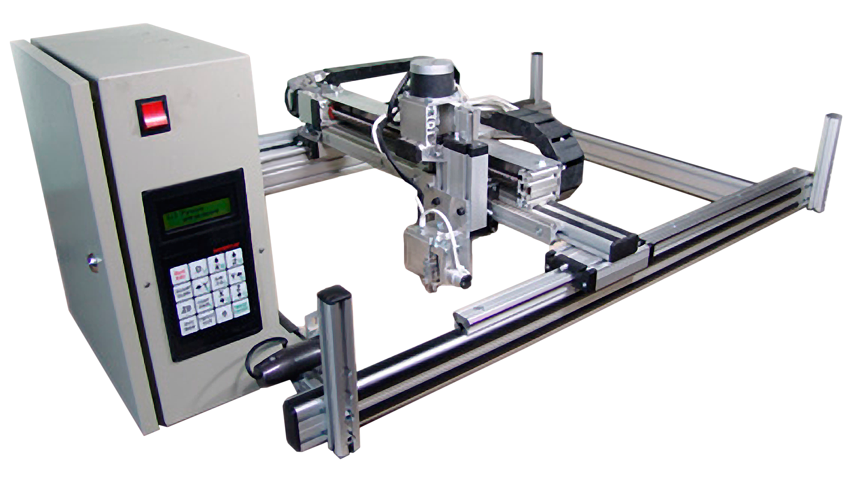

Sauno Ltd., 2013
CONTENTS
1. Introduction 5
1.1. Components of the Graphic Engraving System 6
1.2. Graphic-3KP Technical Specifications 8
1.3. Graphic-2KP Engraving machine - General Layout. Main Units Identification. 10
1.4. Control unit 11
1.5. Z Drive 12
2. Setting-up the machine 13
2.1. Transportation and Storage 13
2.2. Safety Requirements 13
2.3. Grounding 14
2.4. Assembling and Installing the Engraving Machine 14
2.5. Uninterruptible Power Source (UPS). 15
3. Using the Engrave software 17
3.1. Connecting the Machine to your PC 17
3.2. Installing the Engraving Tool 17
3.3. Installing a Workpiece 17
3.4. Preparing to engrave with the Engrave Software 20
3.5. Starting the engraving process: your actions during the engraving 23
3.6. Emergency Stop 24
3.7. Pause Mode 24
3.8. Switching off the Machine and the PC and subsequent resuming of work 24
4. Engraving. Additional Chapters 25
4.1. Manual Mode. Limietd Movement Mode 25
4.2. Copying an Image to the engrave program Using Copy/Paste Commands 26
4.3. Previewing the engraved picture on PC 26
4.4. Engraving Modes: Dot, Amplitude, Combined 27
4.5. HQ (High Quality) Mode 27
4.6. Adjusting the number of a single raw engraving passes 28
4.7. Selecting the picture rasterizing method 28
4.8. Rectangular and Diagonal (Staggered) layout of dots 29
4.9. Enhanced Amplitude Mode 30
4.10. Engraving by parts. Cell Mode 30
4.11. Moving Along the Image Contour 31
4.12. Using the Repeated Pass 32
4.13. Using Different materials for the First and the Second Passes 32
4.14. Contrast Mode 33
4.15. Resuming the work after emergency stop 33
4.16. Launching the engraving process from specific row 34
4.17. Working in the Machine Zero Point Mode 36
4.18. Engraving on oval-shaped workpieces 37
4.19. Engraving on intricate-shaped workpieces 37
4.20. Engraving large-size images by parts 38
4.21. Engraving tiles with no edge indents 39
4.22. Engraving rectangular fragments of picture 39
4.23. Engraving arbitrary-shape fragments. Image mask 40
4.24. Selecting the specific halftones 42
4.25. Engraving the selected halftones 42
4.26. Nonlinear adjustment of strength of the impact 43
4.27. Engraving deep letterings using high impact strength values 44
4.28. Engraving on vertical surface 44
4.29. Creating test color wedge 44
4.30. Creating shortcut for viewing the image during the engraving 45
4.31. Job log 45
5. Installing the Software 46
5.1. Installing the Engrave software 46
5.2. Working with several machines from a single PC 46
6. Maintenance 47
6.1. Replacing the engraving tool (needle) 47
6.2. Replacement of the level sensor sensitive element 47
6.3. Lubricating the guides of X, Y, Z drives 47
7. Troubleshooting 48
7.1. Troubles when switching on the Machine 48
7.2. Manual Mode 48
7.3. Launching the Engrave program 49
7.4. Starting engraving an image ("Start" command) 49
7.5. The machine stops during the engraving, although the job is not completed yet 50
7.6. Distortion of the image in the course of engraving 50
7.7. Magnet does not produce impacts 51
7.8. Horizontal stripes across the image in the X axis 51
7.9. Vertical stripes across the image in the Y axis 52
7.10. Engraving quality problems 52
7.11. Image retouching problem 52
7.12. List of the Machine's error codes 53
8. Checking and adjusting the machine components 56
8.1. Diagnosing and adjusting multifunctional impact head 56
8.2. Magnet adjustment mode 56
8.3. Checking level sensor R 58
8.4. Checking X, Y, Z drives 59
8.5. Checking/disabling end switches 60
9. Replacing the Machine's components 61
9.1. Replacing control board 61
9.2. Replacing control panel 62
9.3. Replacing Power Supply Unit 62
9.4. Replacing Control Unit 63
9.5. Replacingв X, Z, R, M wires. 63
9.6. Replacing X, Y, Z drives 64
9.7. Replacing Z drive of the tracking head on Graphic-3K machines 65
9.8. Replacing Z drive of the tracking head on Graphic-3KP machines 65
9.9. Replacing impact head 66
9.10. Replacing and adjusting the level sensor position 67
10. Monitoring the engraving tool (needle) wear 68
10.1. Installing tool wear monitoring system 68
10.2. Checking the needle wear 69

Introduction
Thank you for choosing our product.
This manual will help you to grasp with the Graphic machine methods of operation. To be able to most efficiently engage all the engraving process control tools, please, read this manual entirely and carefully.
The Graphic-3KP Automatic Engraving Machine is intended for the engraving of raster halftone images on stone, glass, metal and other materials using the impact method. The machine is controlled from a PC, where the Engrave software application, included into the set of delivery, should be installed.

WARNING: This Manual matches the machine control system of v. 8.0. The information contained in this manual, may be changed or modified by the manufacturer with no preliminary notice.

Components of the Graphic Engraving System
Graphic Engraving System is intended for quick and high-quality reproduction of any graphical objects (such as letterings, ornaments, artworks, etc.) on the surface of a hard work piece (stone, glass, metal, plastic, etc.) using the advanced digital impact engraving technology.

Graphic machine components:
- Desktop PC computer or notebook (Figure 1.1)
- Scanner (Figure1.1)
- Automatic engraving machine Graphic-3KP (Figure 1.2, Figure 1.3)
- Computer - engraving machine connecting cable (Figure 1.4)
- Power cable with grounding wire (Figure 1.5)
- Engraving tools (needles) (Figure 1.6)
- Engrave software installation CD (Figure 1.7)
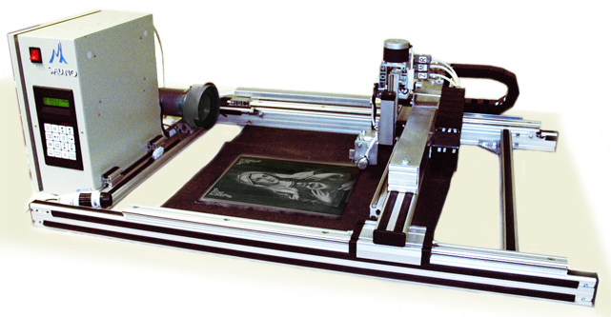
Figure1.3: Graphic-3KP Engraving Machine.

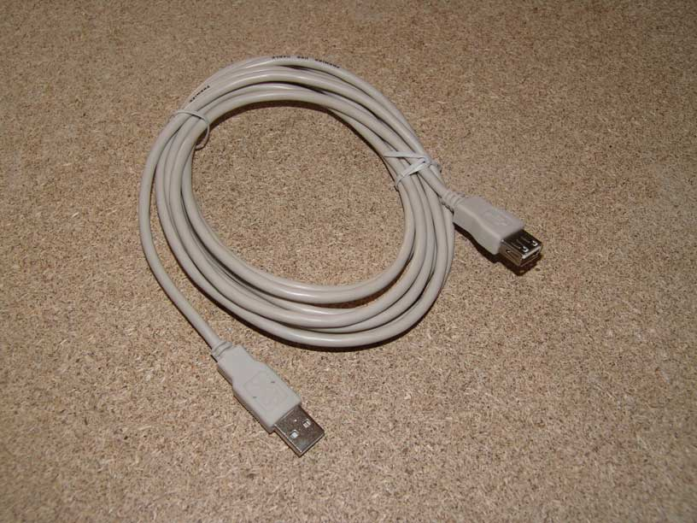  Figure 1.4: computer - engraving machine connecting cable | 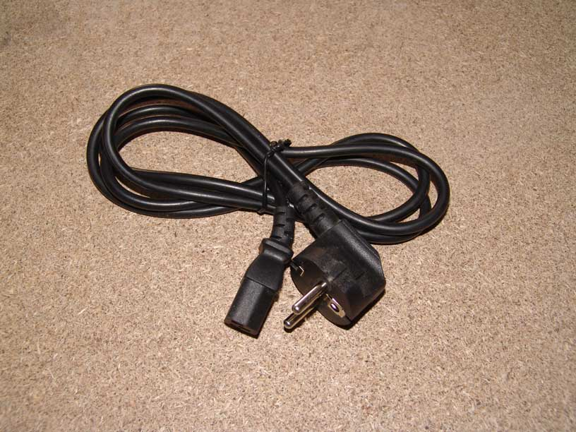  Figure 1.5: power cable with grounding wire
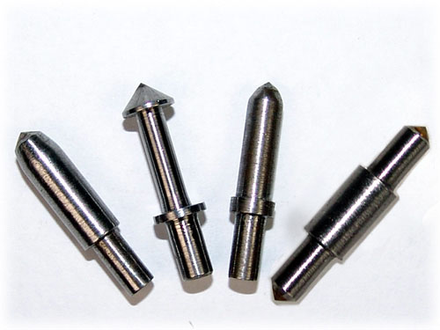  Figure 1.6: engraving tools (needles) | 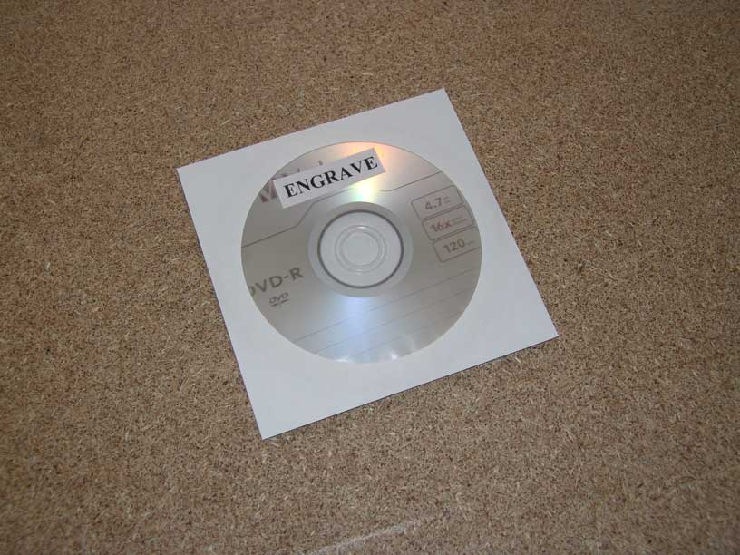  Figure 1.7: software installation CD

Graphic-3KP Technical Specifications

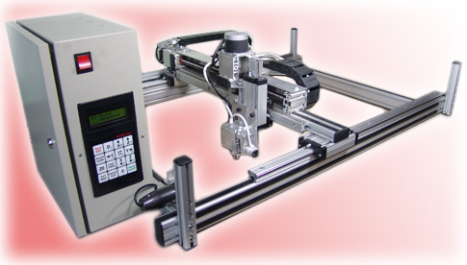
Figure 1.11: Graphic-3KP Engraving Machine (basic version)

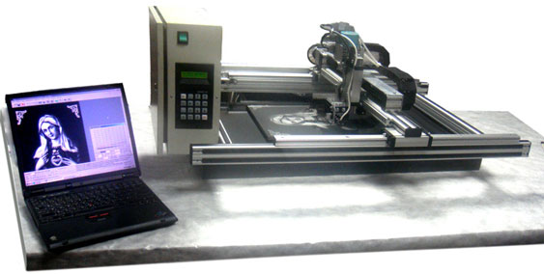
Figure 1.12: Graphic 3-KP Engraving Machine (version for handling large work pieces - legs are dismantled, the machine is laying on the surface of the work piece)

Work field: | 300 mm x 400 mm | 400 mm x 600 mm | 600 mm x 900 mm | 600 mm x 1350 mm
Machine dimensions: | 700 mm x 930 mm x 470 mm | 800 mm x 1130 mm x 470 mm | 1000 mm x 1430 mm x 470 mm | 1000 mm x 1880 mm x 470 mm
Machine weight: | not to exceed 20 kg | not to exceed 25 kg | not to exceed 40 kg | not to exceed 55 kg
Power supply voltage: | ~ 220 V / 50 Hz, ~ 127 V / 60 Hz | ~ 220 V / 50 Hz, ~ 127 V / 60 Hz | ~ 220 V / 50 Hz, ~ 127 V / 60 Hz | ~ 220 V / 50 Hz, ~ 127 V / 60 Hz
Power requirement: | not to exceed 80 W | not to exceed 80 W | not to exceed 80 W | not to exceed 80 W
Processed materials: | stone, glass, metal, plastic mass, timber, etc. | stone, glass, metal, plastic mass, timber, etc. | stone, glass, metal, plastic mass, timber, etc. | stone, glass, metal, plastic mass, timber, etc.
Maximum final Image dimensions (in a single cycle): | up to 300 x 400 mm | up to 400 x 600 mm | up to 600 x 900 mm | up to 600 x 1350 mm
Work piece' thickness: | non-limited | non-limited | non-limited | non-limited
Positioning accuracy: | 0.025 mm | 0.025 mm | 0.025 mm | 0.025 mm
Maximum inclination (deflection from flatness) of a work piece: | 45 degrees | 45 degrees | 45 degrees | 45 degrees
Number of halftones of an image: | up to 256 | up to 256 | up to 256 | up to 256
Image depth: | 0.1 .. 1.0 mm (up to 2.0 mm for marble) | 0.1 .. 1.0 mm (up to 2.0 mm for marble) | 0.1 .. 1.0 mm (up to 2.0 mm for marble) | 0.1 .. 1.0 mm (up to 2.0 mm for marble)
Output: | 300 х 400 mm image: 1.0..1.5 hour (depending on operating mode) | 300 х 400 mm image: 1.0..1.5 hour (depending on operating mode) | 300 х 400 mm image: 1.0..1.5 hour (depending on operating mode) | 300 х 400 mm image: 1.0..1.5 hour (depending on operating mode)
Tool service life: | At least 10 images 300 x 400 mm each (using our proprietary engraving tools) | At least 10 images 300 x 400 mm each (using our proprietary engraving tools) | At least 10 images 300 x 400 mm each (using our proprietary engraving tools) | At least 10 images 300 x 400 mm each (using our proprietary engraving tools)

Graphic-2KP Engraving machine - General Layout. Main Units Identification.

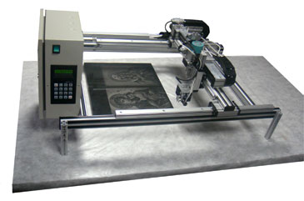
1

3

12

4

2

11

14

13

15

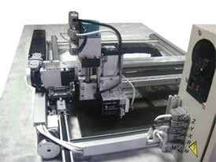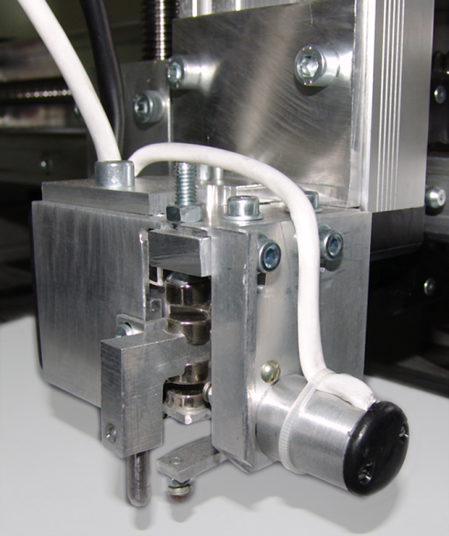
9

8

10

11

2

7

6

5

Figure 1.14: Graphic-3KP Engraving machine layout

- Machine frame  - Х screw drive  - Y screw drive  - Z screw drive  - X drive stepper motor  - Y drive stepper motor  - Z drive stepper motor | - Impact device (magnet)  - Level sensor  - Engraving needle  - Cable cover  - Control unit  - Workpiece  - Work table (may be missing, if the workpiece is laid down onto floor or installed vertically)

Within the text of this manual the words "magnet" and "impact device" shall have identical meanings and describe one and the same unit. Resulting from jointly coordinated movements of X, Y and Z carriages the engraving needle produces the image on the workpiece' surface.

Control unit
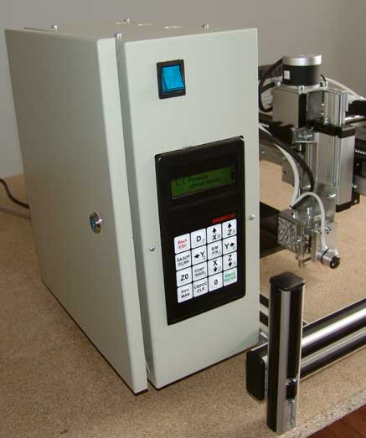  4  3  2  1  Figure 1.15: Control Unit. Front View | 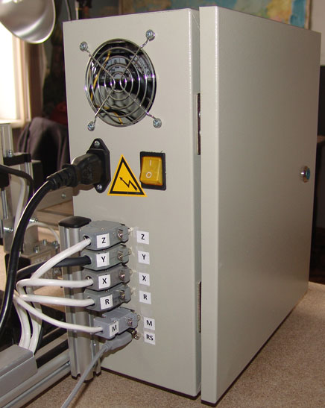  Figure 1.16: Control Unit. Back View
Control unit, installed on the left side of the machine frame, performs the following functions:
- generates control timing pulses for X, Y, Z drives;
- generates control pulses for the magnet;
- provides communication interface between operator and the system.
Front side of the Control Unit (Figure 1.15) contains:
- Machine On/OFF button;
- Operator's control panel with indicator display.
Rear side of the Control Unit (Figure 1.16) combines sockets and connectors for the connecting of the units of the machine with a PC.
Control Unit door is equipped with an individual lock.
Operator's panel (Figure 1.15, item 2) is fitted with the indicator display (item 3) and 16-key keyboard (item 4).
Inner space of the Control Unit contains (Figure 1.17):
- Power source;
- Microprocessor control board;
- Connection cables.
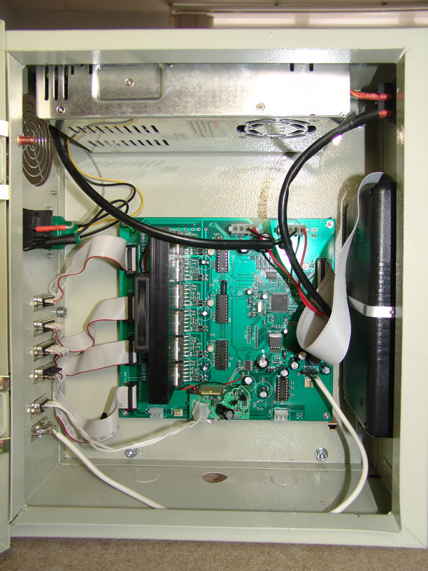  2  3  1  Figure. 1.17: Control Unit - Inside View | 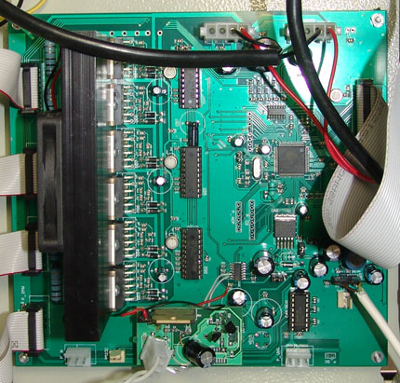  3  2  1  4  Figure 1.18: Control board.

Z Drive
Z Drive includes the following main units:
1. Ball screw spindle drive,
2. Working head with impact device (magnet) and level sensor.
Z-Drive consists of the ball screw and nut assembly with axial bearings and stepper motor Z. This drive is designed to control the multifunctional impact head in the tracking mode. The Work Head consists of the impact device (magnet), touch sensor and level sensor.
The Impact Device (magnet), fitted with the collet clamp to hold the engraving needle, operates as the actuating device, which performs the impact engraving.
Level sensor is the sensitive element, which scans the shape of the workpiece surface.

Setting-up the machine

Transportation and Storage
The engraving machine is allowed for transportation by any modes of transport, including sea, ground and air transportation, in the manner, ensuring the integrity and safety of the product.
The machine must be stored in sealed premises at the environmental temperature from -10°C to +60°C and relative humidity not to exceed 95% (at +20°С).

Safety Requirements
When operating the Graphic-3KP Engraving Machine the following safety requirements must be strictly observed.
* Only those people, who have carefully studies and understood this manual are allowed to operate the Machine.
* The electric mains, powering the Machine, must have properly connected grounding wire. Operation of the Machine without proper grounding in PROHIBITED.
* To prevent potential electric shock, please, take care to regularly check, whether the electric sockets, outlets and cables are in good and proper condition. Make sure, that the electric cables and harnesses are not damaged or squeezed by heavy objects. Do not pull cables and harnesses. Make sure, that electric cables and harnesses have no excessive bends. Damaging of cable or harness wires may result in fire and/or electric shock.
* It is PROHIBITED to operate the machine, when the back lid of its Control Unit is opened.
* When connecting the cables, make sure, that all the connectors are secured properly and reliably. It is PROHIBITED to connect and/or disconnect cables, while the Machine is connected to mains.
* It is prohibited to assembly, repair or perform any maintenance operation, until it is completely physically disconnected from mains.
* In the course and upon completion of the engraving process it is not allowed to blow off the produced dust. Remove the dust with brush or vacuum cleaner.
* Before the installing a workpiece, it is recommended to move the work head to the uppermost position by pressing the <Z ВВЕРХ> button, while in the manual mode, and then to move the work head to the upper left corner of the work area by pressing <X ВВЕРХ>/<X UP> and <Y ВЛЕВО>/<Y LEFT> buttons. Make sure, that the sensitive element doesn't touch the edge of the workpiece.
* In the course of engraving the sensitive element of the level sensor should always remain within the limits of the workpiece.
* When moving the work head in both automatic or manual mode, as well as in the process of engraving, the working tool and the sensitive element of the positioning sensor should not touch the edges of the workpiece and the holding devices. To avoid such undesirable touching, it is recommended to make the allowance, sufficient to bypass the holding devices, when determining the exact dimensions and the location of an image on the workpiece.
* In case of the moving work head in the manual mode, it is necessary to first lift it along the Z axis, and only having this done move the work head in X and Y directions.

Grounding
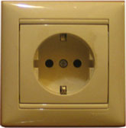  Grounding contact  Figure 2.1: Wall socket with grounding contact | Before you plug the Machine to the wall socket, please, make sure, that mains voltage is 220 / 50 Hz (or 110 V / 60 Hz, where this mains voltage is the industrial standard).  Use only the sockets, fitted with grounding contact, as shown in the Figure 2.1.

To connect the Engraving Machine:
* Use multiple socket (for example, five sockets) extension cord fitted with power supply filter and grounding conductor to connect all the power cables (machine, PC, monitor, scanner). If the UPS device is used, the UPS input cable must be connected to the one of the sockets of the extension cord, while the machine and the computer must be connected to the UPS outputs (or vise versa).
* Make sure, that the grounding circuit has no open failures.

Typical mistakes in connecting the Engraving machine:
THE FOLLOWING CONNECTION MODES ARE PROHIBITED:
* Only the Engraving Machine is grounded, while the PC is connected with no grounding;
* The Machine is grounded not through the wall socket, but using the wire, connected to the Machine' frame.
* Ground contact of the wall socket is idle, that is not connected to the external grounding system, or its wire has an open circuit failure.

The symptoms of the missing grounding:
* Metal parts of the Machine (heads of screws on the Control Unit, steel guides, etc.) are energized, that is you can feel small tingling when touching them;
* Sparking is observed when connecting the RS communication cable of the Machine to the relevant socket of the Control Unit.
* Worsening of the engraving quality - dark element of picture are purely punched.

Assembling and Installing the Engraving Machine
The Machine is designed to operate under the following rated operating conditions: installation inside heated premises with air temperature from +0°С to +60°С, 645 - 795 mm Hg atmospheric pressure, 20% to 95% relative humidity (at +25°С).
Unpack the Machine. It may be delivered both in assembled and in disassembled condition. Work head and computer hardware components (if any) may be dismounted and packed separately. Check the scope of delivery for the compliance with the accompanying part list.

Placing the Engraving machine
The Machine should be installed horizontally or vertically (depending of specific version) on a rigid base nearby the computer, so that the length of connecting cables would be more than sufficient. The maximum distance between the computer and the Machine is determined by the requirements of USB data transmission protocol.

Connecting the Engraving Machine to mains
Since the initial connection stage is vitally important, and considering, that the user may have no sufficient skills in arranging the electric connections, we urge you to pay special attention to the following consideration in respect of the connection procedure.
Before you plug the Engraving machine to the mains socket, please, make sure, that the mains voltage is 220 V / 50 Hz (or alternatively 110 V / 60 Hz for the countries, where this voltage is the industrial standard).
Use exclusively the one-phase socket, fitted with the grounding contact.
Observe the following connection order
1. Connect power cable to the mains socket (Figure 1.5);
2. Connect UPS (see Figure 2.2);
3. Connect the Machine and the PC to the UPS. If your UPS has only two sockets, connect your monitor directly to the free mains socket, instead of connecting it through the UPS;
4. Connect scanner to any free socket of your mains power filter;
5. Connect scanner to the PC, using proper cables, included to the set of delivery of your scanner;
6. Connect the Machine to your PC, using USB cables, included into the set of delivery.
7. Switch on the PC. Wait, till OS Windows has loaded.
8. Switch on the Machine. Informative message, specifying the machine model and software version will be displayed on the indicator screen of the Machine. The Machine will enter the Manual Control ("Ручное управление") mode.

Uninterruptible Power Source (UPS).
* It is extremely recommended to connect the Machine using the Uninterruptible Power Source (hereinafter referred to as the UPS).

Advantages of the UPS:
- UPS will keep your Machine running even in case of an instantaneous mains power failure;
- If mains power is unavailable for the relatively long time (more than several minutes), the UPS will give you enough time to stop the engraving process and to switch-off the Machine without losing any data (see section 3.8). If your UPS has USB feedback connection with your PC, then the Engrave program will suspend the engraving automatically to resume the process, when proper main power is back.

Requirements to UPS
* UPS power must be at least 500 W. The UPS must have at least 2-3 outputs to connect the Machine, the PC and the Monitor (recommended).
* It is desirable, that the UPS has USB feedback with the PC. If this feedback is available, the Engrave program will suspend the work and automatically save the data, even if the operator is away. To enable such feedback, special software must be installed on your PC. This special software is usually supplied together with the UPS.

UPS Connection Diagram
Power mains Socket (grouded)
(с заземлением!)
Input ~220/110 V
Output
Output
Output
UPS
Monitor
Machine
PC
Extension Cable (Power Mains Filter)

Figure 2.2: UPS Connection Diagram

WARNING! Installation of UPS does not abolish the requirement of proper grounding, which is absolutely necessary, irrespectively of whether you have, or have no UPS.

Using the Engrave software

Connecting the Machine to your PC
Grounding of the Machine is MANDATORY. For details, please, see section 2.3.
Before you run the Machine for the first time, please, follow the procedure, specified in section 2.4.
Please, DON'T FORGET:
- to connect data cable to your PC,
- to connect power cable,
- to install the Engrave software on your PC (see section 5.1).
* The Engrave v. 8.0 runs under Windows XPSP3, Windows Vista, Windows 7, Windows8. If you use WindowsXPSP1or SP2 on your PC, please, upgrade current version to WindowsXPSP3.
* Connect the Machine to your PC, using USB socket and standard USB cable, included into the set of delivery of the Machine. No additional drivers are required.
* Alternatively, you may connect earlier versions of the Machine using RS-232 cable and USB-COM adapter.

Installing the Engraving Tool
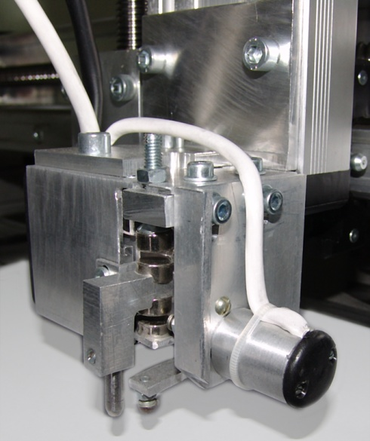  3  4  2  1  Figure 3.1: Installing the Engraving Tool | * Installing the engraving tool (item 1):  - Release the screw (item 2) using the screwdriver;  - Insert the engraving tool into the clamp from beneath;  - Tighten the screw (item 2);  * Sensitive element of the level sensor (item 3) should be positioned by 2..3 mm lower than the engraving tool. If necessary, adjust height of the level sensor using the adjusting screws (item 4).

Installing a Workpiece
Manual Control Mode
Turn the Machine ON, using switch 1 (see Figure 1.15) on the Control Unit. Message "1. Manual Mode" will appear on the screen (item 2, Figure 1.15). In the Manual Mode you may move the engraving tool to the desired position. The tool is moved in three axes: X, Y, Z.

WARNING! While installing a workpiece while in the Manual Mode, pay attention, that the tip of the level sensor and the engraving do not touch the edge of the workpiece. Before installing the workpiece, lift the working head and move it aside in the Manual Mode. When installing the workpiece, make sure, that the sensitive element of the level sensor and/or the engraving tool do not touch the workpiece.
* Push <MAN> button on control panel. The Machine will switch to the Manual Mode. The machine operates in three coordinates: X, Y are horizontal axes coordinates and Z is the vertical axis coordinate. To move the working head along the respective axis, use arrow keys: <X UP>, <X DOWN>, <Y RIGHT>, <Y LEFT>, <Z UP>, <Z DOWN>. The working head keeps moving all the time, while the respective button is kept pressed. Current X, Y, Z coordinates in millimeters will be displayed on the screen.
* Fast/Slow movement mode. Press <F/S> button on control panel.
- Fast Movement Mode: symbol "+" is indicated in the upper right corner of the screen, movement is fast.
- Slow Movement Mode: symbol "+" is in the upper right corner of the screen is off, movement is slow.
* End switches: operate, when the end moving position along the respective axis is reached. For example, when the working head is moved upwards using <Z UP> button, the Machine will stop movement in the upper limit position, symbol "Z1" will be displayed in the right part of the bottom raw on the control panel display. When Z-drive is moved downwards, "Z1" symbol will go off. End switches of X and Y drives work in the same manner.
* In case of the downward movement along Z axis the Machine will stop as soon as the probe of the level sensor has touched the workpiece surface. This prevents damaging of the engraving tool in case of its downward movement.
* Before you start engraving, you should position the impact head at the at least 5 mm distance from the end switches along X axis. This is necessary to do in order to ensure the required acceleration at the high speeds of the working movement. Otherwise the work may be terminated right in the course of engraving, and the Engrave software will generate the end switch error message.
* For more details on the Manual Control Mode, please, see section 4.1.

Installing a workpiece
* Before you start installing a workpiece in the Manual Mode, you should lift up the tool and move it aside.
* Small workpiece (for example, 10 x 15 cm (4 x 6”)). Place the workpiece within the working area of the Machine. If the workpiece is lightweight, fix the workpiece to the table using the double-sided adhesive tape - the workpiece should not swing.
* Large workpiece (for example, a memorial stone 80 x 120 cm (30 x 40”). Place the Machine right onto the workpiece surface, having removed legs, if necessary.
* You don't need to precisely level the workpiece, since the Machine automatically tracks the workpiece leveling in the process of engraving by means of its level sensor.

WARNING! Both the Machine, and the workpiece must lay on the table steadily and rigidly! Swinging is not allowed! Otherwise the engraving process will cause the unwanted vibrations, resulting in deterioration of the engraving quality. If the workpiece does not fit flush with the table surface, put a piece of ordinary paper beneath the appropriate corner of the workpiece. By pushing all corners of the workpiece make sure, that it rests on the table steadily and does not swing.

Moving the tool to the start point
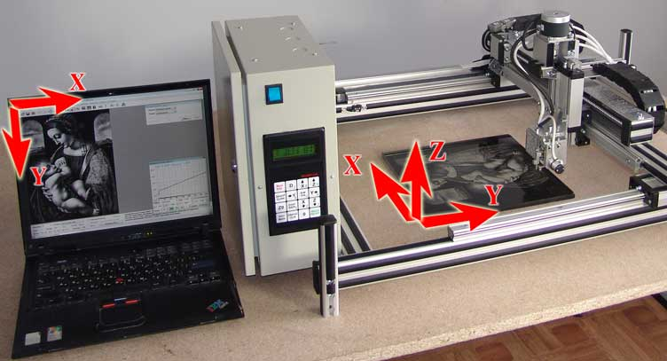
Figure 3.2: PC and Machine Coordinate System
Y
* The start point of an image is in the upper left corner of your PC screen. The upper left corner of the Machine's working area is the corner, where the engraving unit is located. See Figure 3.2 - "zero" point in PC and Machine coordinate systems. Before you start engrave a picture, you should properly install the workpiece on the table, in particular, check, whether the picture is parallel to the upper and the lower edges of the workpiece.
* Checking the positioning of the workpiece: your picture must be parallel to the workpiece edges. Switch to the Manual mode (<MAN> button) and move the edge of the bolt (which serves as the sensing element) of the level sensor to the edge of the workpiece. Now, move the tool head along the edge of the workpiece, using arrow keys. If the distance between the sensitive element and the workpiece edge is changing, your workpiece is wrongly positioned. Adjust the positioning.
* Move the engraving tool to the start point (the point of origin). Tip of the engraving tool cap should be positioned precisely above the left upper corner of your workpiece.

Preparing to engrave with the Engrave Software
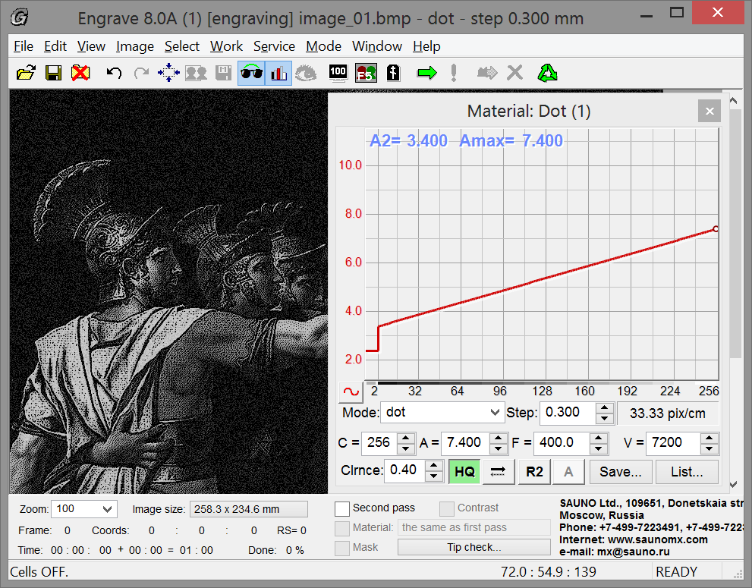  1  5  3  2  4  6  13  7  12  10  11  9  8  Figure: 3.3. Engrave main screen. | - Image  - “Close” button  - “Minimize” button  - Main menu  - Tools panel  - “Material“ panel  - Information panel  - Status line  - Zoom image control  - Working time  - Image size  - Check needle button  - Stone preview button
* Open the Engrave on your PC
* Open your image. Menu command "File/Open…". In the "Open" window select the desired picture (*.BMP file type) and click "Open". The image will be displayed on the screen
* For the training purpose we recommend to use the retouched picture, contained in the "Sample" folder on the installation CD
* The Stone Preview mode is activated by default. You can switch this mode on and off by clicking button 13 (see Figure 3.3). Stone Preview mode is accessible, only when the PC is connected to the Machine, and the Control Unit is switched on.
* Select the desired scale of the image on the screen in the "Zoom" window (item 9, Figure 3.3). Dimensions of the image on the stone in millimeters are displayed in the "Image Size" field (item 11, Figure3.3). It is recommended to set 100% scale. Using 100% scale you will be able to see the image as the dot pattern, exactly in the form, in which it will be engraved by the Machine.

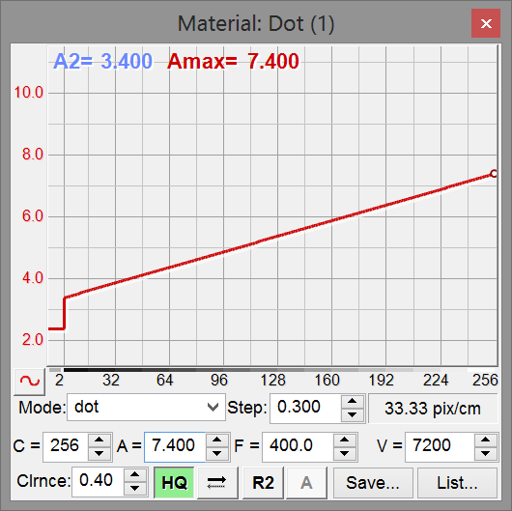  17  19  18  3  5  4  2  1  7  9  16  14  6  8  10  15  13  12  11  Fig. 3.4. "Material" panel. | - Graph of the dependence between the impact strength and the image dot brightness  - Impact force marker  - Engraving mode (dot, amplitude, combined).  - Engraving step  - Image resolution (pixel/cm or inch), depending on step  - Current tone (1 is black, 256 is white).  - Impact strength value A for the current tone, e.g. Аmax=7.400 is the impact force for white tone  - Engraving frequency F, Hz  - Feed rate V, mm/min  - Working gap value L, mm  - "HQ" (high quality) mode, see section 4.5  - Number of passes per line, see section 4.6  - "Raster method" for dot mode or "Diagonal order" for amplitude mode, see section 4.8  - "Enhanced amplitude mode", see section 4.9  - "Save material" button  - Choose material from the list  - Material name  - "Edit A-graph" button  - Current A2/Amax values

Cutting image fragment
* To check functionality of the Machine and for the training purposes it is recommended to engrave the fragment of the image. The most frequently used test fragment is the picture of eyes (see Figure 3.5), since the eyes on the portrait contain the smallest and most meaningful details.
* Select a rectangular fragment. To do this, place the mouse pointer (arrow) to the upper left corner of the fragment, you want to select. Click and drag the mouse, while holding the left mouse button pressed, to the lower right corner of the selected area, then release the mouse button. The selected fragment will be marked by the border. Width and height of the selected fragment will be indicated in the field "Image Size" (item 11, Figure рис.3.3).
* If you have made incorrect selection, you can try again. Simply start selecting the new fragment. The old selection will disappear.
* Cancelling the selection. Left-click anywhere within the Image area. Selection frame will disappear.
* Modifying the selection. Having pressed and holding <Shift> button, place the mouse pointer on the selection frame. The pointer will turn to the double-arrow Having clicked the left mouse button and holding it, move the mouse cursor. Frame edge will move following the mouse cursor movement..
* Cutting the fragment. Menu command "Image/Crop Selection", or "Crop" button on tool panel (item 5, Figure 3.3). Only the selected fragment will stay on the screen.

Setting-up the Engraving Mode and the Gap
* Find the "Material" panel on the screen (item 6, Figure3.3). If the panel is not activated, use the menu command "Window/Material".
* You may select dot, amplitude or combined engraving method from the list of available modes (item 3, Figure 3.4) of the "Material" panel. For more details on different engraving modes, see section 4.4.
* Working gap is the distance from the tip of the engraving tool to the surface of the workpiece. This gap is automatically selected in the process of the engraving. In the course of the engraving the tracking system automatically maintains the gap constant using the level sensor, even if the workpiece surface is inclined or irregular. You can set-up the gap value, using the "Material" panel (see item 10, Figure 3.4).
* If you have changed the Gap value, you should adjust the amplitude and the impact force values A2 and Amax respectively.

Setting-up the Engraving Step
* Select "Step" field from the "Material" panel (item 4, Figure 3.4)
* If your workpiece is made of stone, granite, etc., the most widely used engraving step is 0.300 mm. If your workpiece is small (20 x 30 cm/ 8 x 10” and less), the engraving step may be reduced to 0.200...0.250 mm to make small details look more contracts and sharp. If your workpiece is made of soft material, and the image is large, you may increase the step up to 0.350...0.400 mm. The bigger is the step, the faster is the engraving process, however, smaller details may look less sharp as compared to the smaller engraving step.
* If the workpiece is made of soft material, then having set-up the smaller step (0.250 mm and less), some details of the engraves picture may melt with each other and the picture may look overexposed. So, we recommend to increase the engraving step in case of the soft stone workpieces.

RECOMMENDATION: If you are new to the Machine, select "Dot" mode and set-up 0.300 mm engraving step.

Adjusting picture dimensions and layout
* Measure horizontal dimensions of your workpiece (height and length) with a tape measure
* Click "Stone Layout" button in the Engrave tool panel, or press <F8>. Picture layout on the workpiece surface will appear on the screen.
* Open "Stone" panel. If the "Stone" panel is not on the screen, open using the Window/Stone command from main menu.
* Please, press <Enter> key after each entering of the new value in the "Stone" panel (width, height, margins) to confirm the entered value.
* Set up width and height of the workpiece in millimeters (use "Stone" panel, width and height fields).
* Set up width and height of the picture in millimeters (use "Image" panel, width and height fields). Picture aspect ratio is constant, so if you change picture width, the height will change automatically. Chose picture size so as to provide for the margins on the workpiece edges. For example, if your workpiece width is 300 mm, you beet set up 280 mm picture width to have 10 mm margin on each side.
* Set up the margins from the workpiece' edges. Use "Stone" panel within the four-panel group called "Margins" (top, bottom, left and right margins). If want your image to be located in the center of the workpiece, click "Center X" and "Center Y" buttons. You may also want to set up the required margin value manually. For example, enter "15" in the top margin field and press <Enter>: 15 mm top margin will be set up.
* Left and right margins must be at least 5 mm, the bottom margin must be at least 12 mm and the top margin must be at least 1 mm, otherwise the level sensor probe may go off the limits of the workpiece surface. If the margin value is too small, the respective margin field on the "Stone" panel will turn red. If want to make zero margin, use special cap for the level sensor tip (optional, to be purchased separately).
* Safety area limits, that is the minimal admissible margins area, are indicated on the screen by the red lines. Click "Max size" button to set the maximum possible size of the picture on the workpiece within the admissible margins.
* It is not recommended to modify the minimum admissible margins. However, if you still want to do this, use panel "Stone" and click "Set Safe Margins" option, than in the "Safe Margins" dialogue window enter the desired minimal margins and click "Ok".
* You may adjust the size and the layout of picture using the mouse. Place mouse cursor within the picture area (cursor turns into the black arrow), click and drug, holding the left button pressed. The picture will move on the workpiece surface, and the margins will change. To modify picture size put mouse cursor on the picture edge (mouse cursor will turn into double-arrow), and then click and drug, while holding the left mouse button pressed.
* Quitting the "Stone" Mode. To exit the Stone Mode click "Stone" button in the tool panel.

WARNING! If the workpiece is irregular or oversized, it may be impossible to move the engraving tool precisely to the workpiece corner. If this is the case, you will need to layout the workpiece manually to find the exact location of the upper left corner of picture. Set up picture sizes in the "Stone" Mode. Set zero left and top margins. After choosing the "Start" command the machine will start engraving right from the point, where the engraving tool is currently positioned.

Adjusting Impact Strength
* Press <F5> key on the keyboard. This will turn on the full screen view of the Engrave window. Following message will appear in the lower part of the screen: А2 – impact strength on grays, Аmax – impact strength on whites.
* Adjusting Impact Strength. Use keyboard arrow keys <LEFT> and <RIGHT> to select a parameter to modify (selection turns red) and arrow-keys <UP> and <DOWN> to increase or to decrease the value of the impact strength.
* Press <F5> to quit the full-screen mode.
* You may also adjust the impact strength right in the course of the engraving process.
* Starting from the Engrave v. 8, the impact strength values A2 and Amax are displayed on the graph in the "Material" panel. To modify the parameter value it is sufficient simply to select the parameter you want to change (A2 or Amax), using <F7> key on your keyboard, and to increase or to decrease its value, using arrow keys <UP> and <DOWN>.

Working with the List of Materials
* You may want to save the settings for the specific material (step, impact strength) for the use in the future. Select "Save…" option in the "Material" panel. Use the "Save Material" window to enter the material name whatever you want, such as "Granite", "Glass", etc., then click "Yes" button. Using this function you can save different settings for different materials. Each set of settings can be stored under unique name.
* You can select the previously saved material from the List of material. In the "Material" panel click "List", then in the "Materials List" window select the desired material from the list and click "Ок".
* You may want to change the order of the materials in the list. To do so select the specific material name in the list and use "Up" or "Down" buttons to move it up or down respectively.
* To modify name of the existing material, select it in the list of and click "Rename…". In the "Save Material" change the name and click "Yes" button.
* To delete the material from the list click "Delete" button.
* The "Material List" window contains several "default" material, the settings for which are optimized for different types of engraving method: dot, amplitude and combined. You can customize these settings. To restore the default settings of the list of materials click "Reset…" button in the "Materials List" window.

Starting the engraving process: your actions during the engraving
* Click Start button on the tool panel (green arrow). Click "Start" in the "Move to Start Point" window. The engraving tool will move to the nearest point of the image with the non-zero brightness; thereafter the Control System will automatically set the gap and start working.
* "Time" field in the lower part of the Engrave window shows the time, remaining to the finishing of particular engraving work. Time information is represented as follows: "Elapsed Time" (hh:mm:ss) + "Remaining Time" (hh.mm) = "Total Time" (hh:mm).
* Total time for the particular engraving operation will be displayed as soon as you open specific picture.

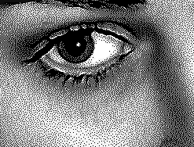  1  1  2  Рис.3.5. Тестовое изображение. | Adjusting impact strength:  On Figure 3.5 the dark-gray areas (item 1) will be engraved with the A2 impact strength, white areas (item 2) will be engraved with the Аmax impact strength.  - To make the image, engraved on the stone, brighter, increase the Amax value. And vise versa, to make the image, engraved on the stone, darker, decrease the Amax value.  - If the Machine fails to punch the dark-gray dots within the dark-gray areas (item 1), that is black color appears on the stone instead of the gray color, you should increase the A2 value.
* Upon completion of the engraving task, the engraving tool automatically lifts up and moves to the start point.
* To modify the value of the tool lift height, use the "File/Options…" menu. In the "Options" window enter the desired value for "Move Z Upon Finish" parameter and click "ОK". The default value of the tool lift height is 15 mm.

Emergency Stop
* For the emergency stop of the engraving process (no resuming):
- use <ESC> button on the control panel;
- or use "Stop" button (marked by red cross) in the Engrave software;
- in case of the faulty termination of the engraving process you can resume the engraving by clicking the "Continue Work" button in the tool panel. For more details, see section 4.15.

Pause Mode
* To enter this mode click "Pause" button (green exclamation mark) in the Engrave program, or press <D> button on the control panel. The machine will finish the then current raw and stop. "Pause" window will appear on the screen. To resume the work click "Continue" button in the "Pause" window, or press <D> button on the control panel. The Machine will resume operation.

Switching off the Machine and the PC and subsequent resuming of work
* Click "Pause" button in the Engrave program (green exclamation mark). The machine will finish the then current raw and stop. "Pause" window will appear on the screen. In the "Pause" window click the "Save & Exit" button. The Engrave will be closed. Now you can switch off the Machine and the PC.
* Switch on the Machine and the PC. Open the Engrave, using the respective shortcut on your desktop. Pending picture and the "Resume Job" window will appear on the screen. Click "Continue". The Machine will resume operation from the point, where the work has been previously interrupted.
* When using the feedback UPS (see section 2.5), in case of prolonged power failure the Machine will stop working and automatically save the interruption point data. After resuming operation, the Engrave program will resume the engraving from the interruption point.

Engraving. Additional Chapters

Manual Mode. Limietd Movement Mode
* The Manual Control Mode serves for moving the engraving tool in horizontal (X, Y) and vertical (Z) planes. To enter the manual Mode press <MAN> button on the control panel.
Screen and keyboard view.
X |  |  |  | 2 | 2 | . | 5 |  | Z |  |  | - | 7 | . | 5
Y |  |  | - | 1 | 0 | . | 3 |  | D | 1 |  | X | 0 | A | +

Codes of the displayed information
* X, Y, Z mean current coordinates in millimeters;
* "D" means the Limited Movement Mode (see below); may take on the values "D", "Ds", "D01", "D1";
* "X0", "Х1" indicate activation of the end switches of the Х-axis carriage: "X0", "X1", the Y-axis carriage: "Y0", "Y1" and the Z-axis carriage" "Z0".
* "A" indicates the Absolute Coordinates Mode and shows, that the tool has been moved to the zero point of the Machine in the Engrave program (only if the machine zero point has been activated).
* "+" indicates the Fast Movement Mode. Switching on and off by <F/S> button.

* Exit <ВЫХ>/<EXIT> button serves for the exiting from the manual Mode to the Main Menu.
* Axis Movement Buttons. Arrow-keys <X UP>, <X DOWN> serve for the Z-movement. Arrow-keys <Y RIGHT>, <Y LEFT> serve for the Y-movements. Arrow-keys <Z UP>, <Z DOWN> serve for the Z-movements.
The tool head keeps moving all the time while the respective movement key is kept pressed. In so doing the values of respective coordinates (X, Y, Z) are changing.
* End Switches. When the tool reaches the limit of the work area of the machine, the respective end switch is activated and the respective movement stops. In so doing the message, indicating the code of respective end switch, such as "X0", "X1", etc., is displayed in the lower part of the screen. If the end switch has triggered, the respective movement is possible only in the opposite direction.
* There is only one upper "Z1" end switch on the Z-axis. When the tool head moves down, it stops when the level sensor tip touches the workpiece surface. This prevents damage of the engraving tool in case of the uncontrolled downward movement.

* Fast and Slow Movement. Press the <F/S> button. Symbol "+" will appear in the lower right corner, indicating the Fast Movement Mode. In this mode the movement along the selected coordinate is fast. To quit the Fast Movement Mode press the <F/S> button again. Symbol "+" will go off.

* Zero Point.
- Key <CLR> resets X, Y, Z coordinates to zero.
- Key <0> return the tool to the point with zero X,Y, Z coordinates. You can stop the movement at any time by pressing the <ESC> key.
WARNING! <Z0> key resets to zero only Z coordinate. This function is used in the 3D Scanner Surface Mode.

* Limted Movement Mode. Symbol "D" is displayed in the bottom raw, while in the normal mode. In this mode the respective movement along the selected coordinate axis proceeds, as long as the relevant arrow-key on the keyboard remains pressed. Repeated pressing <D> key on the control panel results in selecting of one of the following modes:
- "Ds" - single-step movement, usually by 0.025 mm steps
- "D01" - movement by 0.1 mm steps
- "D1" - movement by 1.0 mm steps
- "D" - continuous movement mode.
The Limited Movement Mode is especially convenient, in case you need to move the tool by a small distance. While in the Limited Movement Mode, the respective coordinate changes by the value, not exceeding the given one, for example, by 1.0 mm.
* If you have entered the Limited Movement Mode by mistake, you can return to the normal mode by pressing the <D> key, till "D" symbol is displayed on the screen.

Copying an Image to the engrave program Using Copy/Paste Commands
This feature allows you to copy an image from Adobe Photoshop to Engrave using standard copy-paste procedure.
Do the following:
* In Adobe Photoshop select the entire image or the desired rectangular fragment thereof. The image must be converted into halftone (256 gray scale) palette. To make a selection:
- to select the entire picture, use the "Select/All" command, or use <Ctrl-A> hotkey combination;
- to select a fragment - select the "Rectangular Marquee Tool" from the tool panel and select the fragment you want, using the rectangular marquee.
* Copy the selection:
- Use "Edit/Copy" command, or <Ctrl-C> hotkey combination, provided the image consists of a single background layer;
- Use "Edit/Copy Merged" command, or <Shift-Ctrl-C> hotkey combination, provided the image consists of several layers;
* Now go to the Engrave program. Use "Edit/Paste" menu command, or <Ctrl-V> hotkey combination. Copied fragment will appear in the Engrave window.

Previewing the engraved picture on PC
The "Engrave" allows you to preview the final picture as the result of the modeling of how will this image look like, having been engraved on the selected stone. The quality of the stone and its unevenness can be set up in the program. This method allows you to make sure, whether the picture has been properly retouched, before you start actual engraving. If, using the preview function, you see, that some parts of the simulated image have disappeared, for example, haircut, face wrinkles, you need to retouch the image to make it fit for the particular stone.
* To enter the Preview Mode, use the "View/Preview Engraving on Stone" command. Make sure, that respective checkbox is clicked. You may use the "Preview on Stone" button on the tool panel (button marked with the goggles symbol), or press the <F11> key.
* Preview Mode is accessible, only if the Machine is ON and connected to PC. Otherwise, the respective warning window will be displayed on the screen.
* When the Preview Mode is selected, the simulation process may take some time, which depends on the simulated image sizes. The modeling is made in the background mode. When the modeling is in progress, green semi-transparent "S" symbol and progress indicator are displayed on the Engrave screen over the image.
* Use "View/Stone Quality…" menu or <Ctrl-F11> hotkey combination to enter the stone quality parameters. In the opened window "Stone Quality" specify the degree of the stone unevenness - the more is the number, the more irregularities are on the stone. Click "Ok" button..

Engraving Modes: Dot, Amplitude, Combined
The Machine is capable of engraving pictures in Dot and Amplitude Modes. Switching between the modes is made from the Engrave program.
* Mode Selection. In the Engrave program use the "Material" panel to select from the "Mode" list one of the following operating modes: "Dot", "Amplitude" or "Combined".

Dot Mode
* The Dot Mode is the default operating mode set up in the Engrave program.
* The Mode is based on the following principle: the brighter (whiter) is the picture area, the more dots are engraved on the workpiece surface, that is brighter areas consist of the bigger number of dots as compared to the darker areas. In addition to that, the brighter (whiter) is a dot, the stronger if the impact. Dot density is controlled automatically, and the impact strength is set up using the "Material" panel.
* Please, note, that in the Dot Mode the tone brightness is determined by the density of dots on the picture (the Engrave calculates the number of dots automatically) and the impact strength (which is controlled through the variation of values of A2 and Amax amplitudes).

Amplitude Mode
* In this mode the dots on the workpiece surface are located equidistantly and form the rectangular mesh. Each tone brightness is determined exclusively by the impact strength.

Combined Mode
This mode is the enhanced version of the Dot Mode. This mode makes use of the advanced dot placement method.
* Special features of Combined Mode:
- Dot pattern structure reminds what you can see on a manually engraved artwork. There are no rows. There is no dot mesh, like in case of the Dot Mode. There are no repeating "patterns" or "dot artifacts", like in case of the Dot Mode;
- When the Combined Mode is used, the picture is being engraved brighter, than in case of the Amplitude or Dot Modes.
* When the Combined Mode is used, step (item 4, Figure 3.4) has to set up as follows:
- Left -click the button to the right from the word "Step" in the left part of the "Material" panel;
- In the drop-down list left-click the required step value.
* Combined Modes feature not only different step values, but also different densities of dots. For example, for the step value of 0.300 you can select one of the following modes:"0.300А", "0.300B", "0.300C". In the "A" mode the density of dots is minimal, while the engraving speed is maximal. In "C" mode the density of dots if the maximal, while the engraving speed is minimal.

HQ (High Quality) Mode
In this Mode each dot is engraved in two passes, that is when the tool head moves back along the already engraved row, the Machine engraves this row one more time. This results in better engraving quality as compared to the single-pass engraving modes, since the engraving tool in the two-pass mode is positioned more precisely.
* To enter into the "HQ" mode, click the "HQ" button on the "Material" panel (item 11, Figure 3.4). When this button is pressed, the HQ Mode is active. To quit the HQ Mode, click the "HQ" button again.
* In the HQ Mode we recommend to decrease the impact strength Amax (impacts on whites) as compared to the values used in the normal modes. The weaker impacts, made in double-pass mode, give better picture quality as compared to the single-pass mode.
* The HQ Mode requires twice more time for the engraving process as compared to the ordinary modes.
* If you have selected the HQ Mode plus the "Second Pass" option, each row will be engraved in four passes.

Adjusting the number of a single raw engraving passes
* The Machine is capable to engrave a single raw in up to four passes. In the "Material" panel click "Set number of passes" (see item 12, Figure 3.4). In the opened menu select the desired option:
- Single pass (speed)
- Two passes (quality). Corresponds to HQ Mode
- Three passes (depth). Use for engraving of deep-caved letters
- Four passes
- One-way Mode. In this Mode the Machine engraves row in one pass, and the return pass is idle. Time consumption increases twice as compared to the single-pass mode, but the tool positioning errors considerably reduce.

Selecting the picture rasterizing method
* This function is accessible in the Dot engraving mode.
* The Engrave program allows you to select the half-tone to raster image conversion method. The Figure below illustrates application of the three available methods.
* To select the image conversion method click button 13 (see Figure 3.4) in the "Material" Menu. Dot mode will be set up in the field "Mode" of the "Material" panel (see Figure 3.4, item 3).
* Modified method R2 is the method, which the Engrave program uses by default.

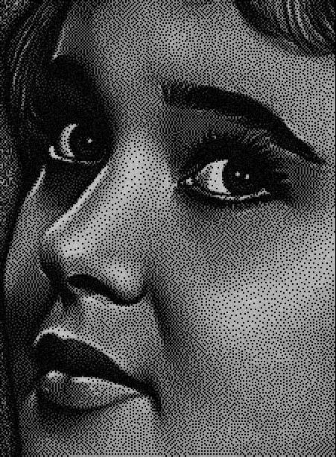 | 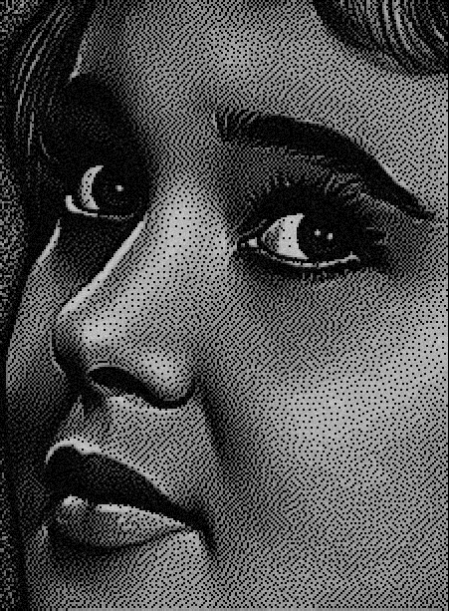 | 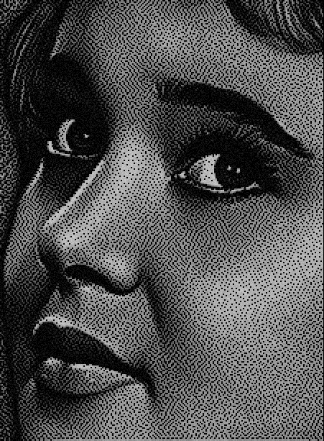
Default raster (R1) | Modified raster (R2) | Diagonal raster (R3)
Figure.4.1: Image rasterizing methods

Rectangular and Diagonal (Staggered) layout of dots
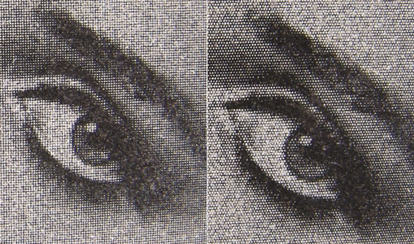
Figure 4.2: Rectangular (left) and diagonal (right) layouts of dots
* If the Amplitude Mode is selected, then most usually the engraved dots will form a rectangular grid. Horizontal and vertical distance between the dots are the same and equal to the selected step value. The step value is set in the "Material" panel, see item 4, Figure 3.4. When the diagonal dot layout mode is selected, staggered dot order will be used instead of the grid dot order.
* This function is accessible only in the amplitude engraving mode. Amplitude Mode must be set in the "Mode: field of the "Material" panel, see item 3, Figure 3.4.
* To switch the dot layout mode, use the "Engrave Points in Diagonal Order" button in the "Material", see item 13, Figure 3.4. When the button is clicked (green), diagonal (staggered) dot layout mode is activated. To disable the mode click the same button once again.

Enhanced Amplitude Mode
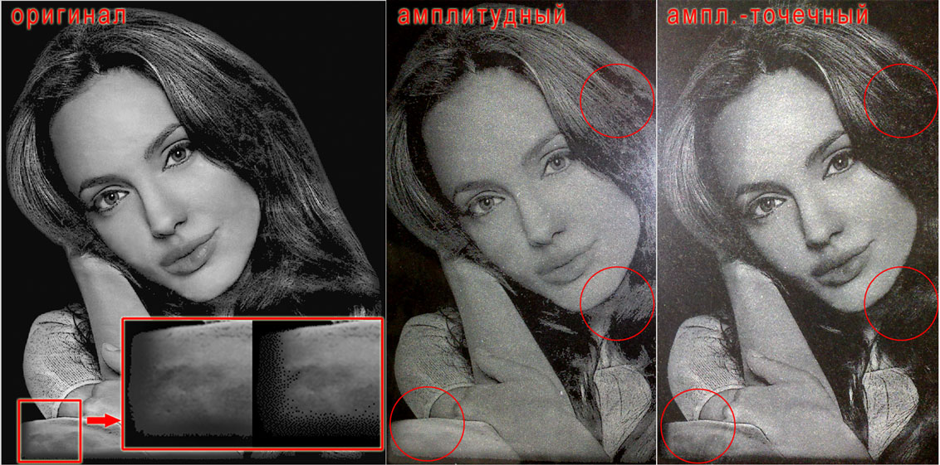
Figure 4.3: Amplitude and Amplitude-Raster modes
* This functions is accessible only in the Amplitude Mode.
* To switch this mode on, click the "Enhanced Amplitude Mode" button in the "Material" panel, see item 14, Figure 4. When the button is clicked (green), the mode is activated. To switch the mode off click the button once again.
* In the Amplitude-Raster Mode an image is engraved in the same way, that in the Amplitude Mode, except the dark-gray areas, which are engraved in the Dot Mode. This ensures smooth gradient between dark-grays and blacks, see the red-marked area on Figure 4.3. Actual changes are displayed on the Engrave screen.
* To modify settings of the Amplitude-Raster Mode, click the mode activation button (item 14, Figure 3.4), while holding <Ctrl> key on your keyboard. "Amp-Dot Mode" window will open.
* "Gray halftone limit" sets the range of halftones (from 1 to the set value, where color 1 means black and color 255 means white).
* "Initial brightness level" sets the deepness of the effect: the lesser is the value, the deeper is the effect on the image.
* To strengthen the effect the "Gray halftone limit" setting must be increased, while the "Initial brightness level" value must be decreased.

Engraving by parts. Cell Mode
* Cell Mode enables considerable time savings, when engraving the images, containing large black areas, such as:
- picture in the frame;
- several independent fragments, combined in the one and the same composition, for example, two portraits (on the left and on the right), or a portrait and a cross;
- letterings;
* To witch on the Cell Mode, use "Mode/Cell Mode" command. If the respective menu point is checked, the Mode is on. To switch the mode off, use the same command again.
* When the Cell Mode is on, the Engrave divides the image into separate fragments so that to exclude idle passes of the tool head within the black areas. This considerably reduces the engraving time.
* Diving into cells is the automatic process, requiring no interventions on the part of the operator. When an image has been opened, or when the material settings have changed, the Engrave will newly divide the image into cells and calculate the tool movement trajectories. Trajectories calculation is the background process. When this process is in progress, semi-transparent "T" indicator will be displayed above the image.
* When opening an image, a message, looking like: "Cells: 122, time reduced: 05 hour 01 min 30 sec. (153%)" will appear in the status bar of the Engrave program. Reduction of time means, that in the Cell Mode the machine will finish the job by 5 hours faster, than it would in case the Cell Mode is off. If the time saving for a particular picture is insignificant, the Engrave will not divide this image into cells, and "Cells off" message will appear in the status line.
* During the work the then current cell, that is the part of the picture, being currently engraved, will be marked blue. Non-processed part of the picture will be marked red.

WARNING! In the cell Mode the machine may finish a part of the image and then to move to the different part. While the entire engraving job is not finished, the picture on the workpiece may have missing fragments. This is normal. By the time of completion the engraving job the machine will finish all the picture entirely.

Moving Along the Image Contour
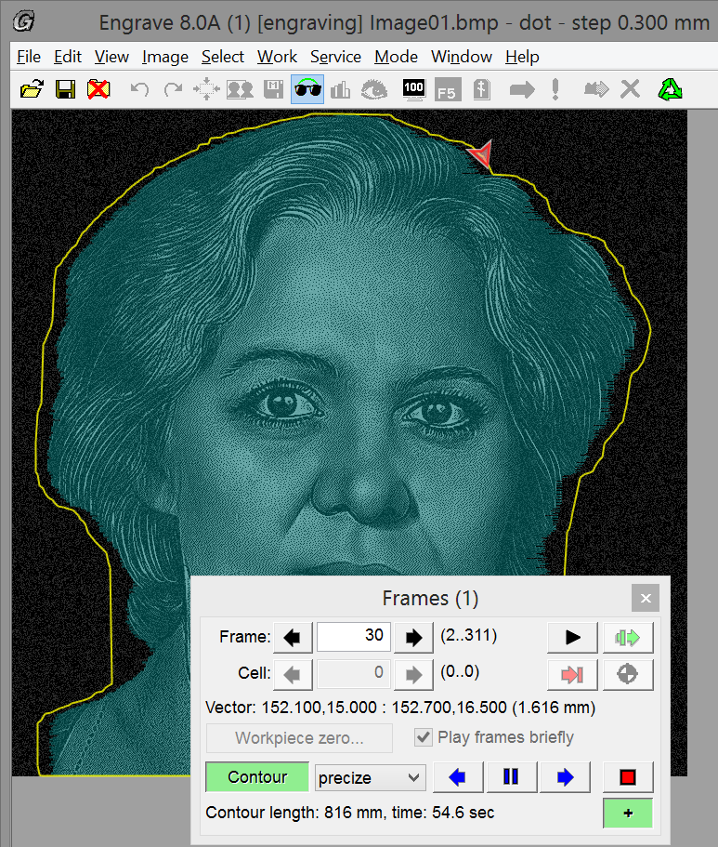  9  6  5  8  7  4  3  2  1 | - "Move along contour" button  - Contour  - Current position of the instrument in the course of the outlining  - "Frames" panel  - Outline backward button  - "Pause" button  - Outline forward  - "Stop" button  - Change outlining speed button (fast/slow)  The image contour outlining function allows you to check positioning of the picture on the stone surface to make sure, that the tool will remain within the workpiece limits within the entire engraving job. When outlining the contour the software takes into account both the accelerated/decelerated movements of the tool, and the idle passes between different image fragments (cells). Outlining the contour must start after the tool is moved to the start point and the image sizes are set in the Engrave program, that is right before the beginning of the engraving.
Figure 4.4: Outlining the image contour

Procedure:
* Before you start the outlining process, lift the instrument above the workpiece, since the level tracking function is off while outlining.
* In the Engrave program use the menu command "Work/Move along contour (Ctrl-F9)…". or click button 1 (see Figure 4/4) on the tool panel.
* In the "Move along image contour" window click "Forward" button to move along the image contour clockwise, and button "Back" to move along the contour counterclockwise. The tool will start outlining the contour of your image.
* When outlining an image current position of the tool is displayed on the screen of the Engrave program (item 3, Figure 4.4). Control panel screen displays current coordinates, just like in the manual mode. When the outlining if finished the tool will move to the start point, like in case of engraving.

Action during the outlining
* You may control the outlining trajectory, using the Machine control panel keys, or from the "Frames" panel in the Engrave program (item 4, Figure 4.4).
* To terminate the outlining, press <ESC> on the control panel, or click "Stop" (item 8) in the Engrave window. After the tool has stopped, you may move it to the zero point by pressing <MAN> and thereafter pressing <0> keys on the Control Panel.
* To pause the outlining press <Y LEFT> or <Y RIGHT> arrow keys on the control panel, or click "Pause" button, item 6, in the Engrave window. To resume the outlining, press <Y RIGHT> or <Y LEFT> arrow keys on the Control Panel, or click "Forward"/"Back" buttons, items 5, 7, in the Engrave window.
* When the outlining is paused, you can lift up or move down the tool by pressing <Z UP> or <Z DOWN> keys on the Control Panel. This is useful, if you want to move the tool lower to ensure better control, or vise versa, to lift the tool more to avoid undesired touching with some protruded parts.
* To change the outlining direction, press <Y RIGHT> or <Y LEFT> keys on the Control Panel. The Machine will be switched to the pause mode. Then press <Y RIGHT> to resume the outlining forward, or <Y LEFT> to resume the outlining backward.
* To adjust the outlining speed press <F/S> on the Control Panel, or click "+" (item 9) in the Engrave Window. This switches the Machine between fast/slow outlining modes. In the fast outlining mode "+" symbol is displayed on the Control Panel screen, "+" button in the Engrave window is displayed clicked (green).

Using the Repeated Pass
* The Repeated Pass enhances image quality in case the workpiece structure is non-uniform.
* Toy may also use the HQ Mode (see section 4.5) instead of the repeated Pass.
* To switch off the Repeated Pass, check the respective checkbox in the "Work/Second Pass" menu. You can do this both before the commencement of work, and right in the course of engraving.
- If the "Second Pass" checkbox is checked, then upon the completion of current job the tool head will return to the start point and commence the repeated engraving pass.
- If this checkbox is not checked, then upon completion of current job the Machine will move tool head to the start point and stop.

Using Different materials for the First and the Second Passes
You may set different material for the repeated pass. This gives several additional opportunities, including:
- You may set the first pass in the Amplitude Mode and the Second pass in the Dot Mode, or vise versa. In some cases combination of modes gives better results as compared to the use of just a single mode or the repeated pass in the same mode.
- You set stronger of weaker impact for the repeated pass.
To adjust the material parameters for the repeated pass do the following:
* In the "Material" panel set the first pass material parameters: mode, step, impact strength, gap. Save the material. Click the "Save…" button in the "Save Material" and enter the name of the material toy want and click "Yes".
* Similarly, you can set the parameters of the second pass material. In so doing the first and the repeated pass steps must be the same.
* In the "Material" panel click the "List…" button, in the "Materials List" window select the first pass material and click "Ок". In the "Material" panel the first pass material name will appear.
* In the Engrave information panel check the "Second Pass" checkbox. Additionally check the "Material" checkbox below. Now, in the list box select the material for the repeated pass and click "Ок". The selected material' s name will appear to the right from the "Material" checkbox.
* To select another material for the repeated pass, click the button to the right from the "Material" checkbox. List-box of materials will open be opened.
* To cancel the repeated pass material, deselect the "Material" checkbox. "The same as first pass" lettering will appear on the button to the right from the checkbox.

Using three and four passes
* Create two materials for the first and repeated passes.
* To make use of the four-pass engraving, Дselect the HQ mode for the first and the repeated pass materials.
* To make use of the three-pass engraving, select the HQ mode for the first pass material, and don’t use the HQ mode for the repeated pass material.
* If you have the Engrave version 8, you can set up to 4 passes of every single row (see section 4.6).

Contrast Mode
Contract Mode ensures the obtaining of more contrast picture after the repeated pass.
* Contrast Mode becomes accessible, when the "Second Pass" option is selected.
* To activate Contrast Mode select the "Work/Contrast" menu option, or check the "Contrast" checkbox in the Engrave information panel. You can do this both before you start the job, and when the first pass of the engraving job is in progress. To switch the mode off select the "Work/Contrast" menu command, or uncheck the "Contrast" checkbox in the information panel.

Resuming the work after emergency stop
You may want to resume the work after the emergency stop, that is after:
- Accidental switching the Machine and/or your PC off when the work is in progress because of power failure or the operator's mistake;
- Emergency termination and/or Аварийное завершение, "hang-up" of the Engrave program;
- Erroneous termination of program operation by the Operator, for example, accidental use of <ESC> button on the control panel or clicking "Stop" button in the Engrave;
- False leaving of the workpiece limits (error#7: level changed greatly).

WARNING! To avoid emergency stops caused by power failures it is extremely recommended to use Uninterruptible Power Source (UPS). For details see section 2.5.

When the resuming of work is possible:
* It is possible to resume the job from the point of interruption, provided the workpiece and the Machine have not been moved to another position;
* If the "Machine reference mode" is ON (see section 4.17), you can resume the job in all the above power failure instances;
* Of the "Machine reference mode" is OFF, you can resume the job in all the above power failure instances, provided however, that the Machine has not been switched off, since the workpiece zero point is lost in case of the switching off the Machine.

How to resume the job ( "Machine reference mode" is ON):
* Turn on the Machine and/or the PC, in case they have switched off;
* If the Engrave has been closed, launch it again. Move the tool to the zero point of the Machine, in case the Engrave has requested you to do this;
* In the Engrave program open the image you have been engraving at the time of the emergency stop, using the "File/Open Last" command;
* Click "Continue work" button on the tool panel, or use the "Work/Continue work" menu command. The tool will first move to the zero point of the machine, and then to the beginning of the unfinished row;
* "Continue work" window will appear on the Engrave screen. Click "Continue" button. The machine will set the gap and resume engraving from the row next to the interrupted row.

How to resume the job ( "Machine reference mode" is OFF):
* You can resume the job from the interruption point, only provided the Machine has not been switched off;
* If the Engrave is closed, launch it again;
* In the Engrave program open the image you have been engraving at the time of the emergency stop, using the "File/Open Last" command;
* Click "Continue work" button on the tool panel, or use the "Work/Continue work" menu command. The tool will be moved to the beginning of the row next to the unfinished row;
* "Continue work" window will appear on the Engrave screen. Click "Continue" button. The machine will set the gap and resume engraving from the row next to the interrupted row.

Launching the engraving process from specific row
Sometimes you may need to start engraving the picture not from the very beginning, but from some specific row. This function is useful, if the Machine operates in the Cell Mode. You can start engraving the picture from given row by using the "Frames" panel (see item 1, Figure 4.5).
In the Engrave application the frame means the then engraved row of the image, or the idle pass, that is the transition of the tool head between different cells of the image.

View Frames Mode
This mode allows you to start the engraving from a specific frame.
* To enter the Frame View Mode, open the image and use the "Mode/Manage Frames" menu command, or alternatively, press <Ctrl-F7> on your keyboard. "Frames" panel (see item 1, Figure 4.5) will appear on the screen.
* To quit the Frame View Mode, close the "Frames" panel by clicking the cross button in the right upper corner of the panel, or use the "Mode/Manage Frames" menu command, or alternatively press <Ctrl-F7> on your keyboard. "Frames" panel will be closed.
* To select the required frame, left-click on desired row of the image. Red line (see item 2) will appear on the image, and the current frame number will appear in the field "Frames" (item 3) of the "Frame" panel. You may also enter the desired frame number in the "Frame" field (item 3), and then press <ENTER>.
* To move the tool to the beginning of the selected frame, click red arrow button (item 14) in the "Frames" panel. The tool will be moved to the beginning of the selected frame.

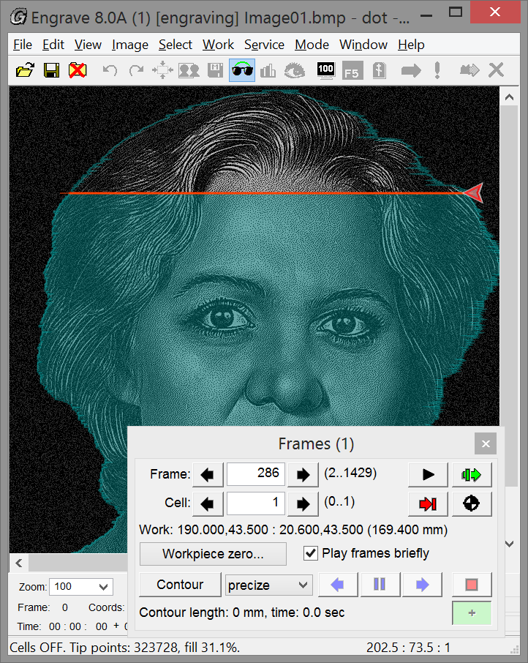  9  8  10  11  14  15  16  7  17  6  5  3  1  4  2  13  12 | - "Frames" panel  - Current frame  - Current frame number field  - Go to previous frame button  - Go to next frame button  - Total number of frames  - Current frame type and coordinates  - Current cell number field  - Go to previous cell button  - Go to next cell button  - Total number of cells  - Modeling passes along trajectory button  - Move to the workpiece zero point button  - Move tool to the beginning of the selected frame button  - Start engraving from selected frame button.  - Workpiece zero button.  - Number of current frame being engraved
Figure 4.5: "Frames" panel.

Workpiece zero point
* Workpiece zero point means the position of the tool (needle) before commencing the engraving. In the Manual Mode tool coordinates are presented in the workpiece coordinate system, that is X=0.0 and Y=0.0 correspond to the zero point of the workpiece. When the start engraving command is entered, the Machine control software automatically stores the workpiece zero point. Upon completion of the engraving of an image the tool automatically returns to the workpiece zero point. If the engraving process has been interrupted, you may return the tool to the workpiece zero point by pressing <0> key on the machine control panel while in the Manual Mode.
* The tools moves from one frame to another in the workpiece coordinate system, therefore the workpiece zero point must be set:
- If the engraving process has been started and later interrupted, or successfully completed, then, when moving the tool from one frame to another frame, the workpiece point is the position of the tool before the beginning of engraving;
- If the engraving process has not been started yet, then you need to move the tool to the initial point in the manual Mode, using the control panel keys. Having this done, in the "Frames" panel you need to click the "Workpiece Zero..." button (item 16), and in the "Workpiece zero point..." window click the "Set current position as WPZ" button. The program will remember current coordinates of the tool as the new workpiece zero point.

* To move the tool to the zero point:
- From the Machine control panel: press <MAN> key, lift the tool buy pressing <Z UP> key, press <0> key to return to the workpiece zero point;
- from the Engrave program: in the "Frames" panel click the Go to the workpiece zero point button, item 13.

When starting the engraving from the given frame
* Open "Frames" panel using <Ctrl-F7>. Chose the desired frame in the "Frames" panel;
* In the "Frames" panel click the "Start engraving from selected frame" button, item 15;
* In the "Move to start point" window click the "Start" button. The tool will move to the beginning of the selected frame, and the Machine will start engraving.

Working in the Machine Zero Point Mode
In the Machine Zero Point Mode (so-called "absolute coordinates mode") the coordinate system is precisely referred to the zero point of the machine, which is located in the nearest left corner of the Machine and determined by the triggering of the end-switches X0,Y0, Z0. Operating the machine in the Zero Point Mode allows you to resume the work from the interruption point in case of the power supply failure of both the control PC and the machine, provided, however, that the Machine is fully functional and the workpiece has not been moved in reference to the Machine. You can resume the work after the power failure, even if your system is not fitted with UPS.

Zero Point of the Machine
* To switch ON/OFF the Machine Zero Point Mode use the "Mode/Machine reference point" command. When the Mode is on, the program will propose you to move the tool to the zero point of the machine.

* You have to move the tool to the zero point of the Machine in following cases:
1. After each switching-on of the Machine's control unit;
2. After the triggering of the end switches X1, Y1;
3. After the "loss" of steps, for example, if the drive of some of the axial movement (X, Y, Z) has stuck.

* In the (1) and (2) cases the Engrave program will offer you to move to the zero point immediately after the Machine has been re-started, or after the "start engraving" command. In case (3) the movement to the zero point should be made from the Engrave program using the "Mode/Move to machine reference" command, or be pressing <Ctrl-F6> on your keyboard.
* When moving the tool to the zero point the Engrave will open warning window and offer you to move the tool to the zero point. You should click "Yes". The tool will be moved to the nearest left corner of the machine (where the control unit is located). The tool will be first moved up (along Z axis), then along Y axis, and finally along X axis.
* If you have refused from moving the tool to the Machine Zero Point, (if you clicked "No" button), the Engrave will continue operation. However, after entering "Start: command (clicking "Start" button) the program will once again ask you to move the tool to the zero point of the Machine.
* Note, that after the moving to the zero point of the Machine, "A" symbol will be displayed in the manual mode in the bottom row of the Control Unit Display.

Engraving on oval-shaped workpieces
Start point  Figure 4.6: Engraving ob oval workpiece | If you work with oval-shaped workpieces, the start point should be the central point of the workpiece along X axis and upper point of the workpiece along Y axis instead of the upper left corner, that is the topmost point of the oval (see Figure below).  * Switch on the manual Mode (<MAN> key) and move the tool to the start point of the workpiece (see Figure);  * In the Engrave program open the "Work region" panel, using the "Window/Work region" menu command (see Figure 4.7);  * Select "Ellipse" from the "Shape" list box of the "Work region" panel;  * Set the oval proportions, taking into account sufficient edge margins. Select "Proportional" from the "Style" box menu in the "Work region" panel. Set the respective width and height in the "Prop." field.
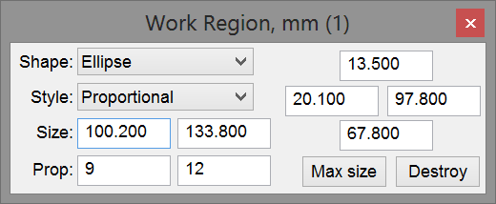  Figure 4.7: "Work region" panel | For example. if an oval workpiece has the dimensions of 11х14 cm, then in view of 1 cm margins on each side the proportions should be 11-2=9 and 14-2=12.  * Select the desired oval area on the picture using the mouse. The area will be selected in accordance with the pre-set proportions.
* Set picture size, using the "Image/Image size…" command. The oval area size should be less than the workpiece size by the value of margin, for example, by 100 m on each side. In our example we should set 90 mm width and 120 mm height.
* Start the engraving process by clicking "Start" (green arrow) button.

Engraving on intricate-shaped workpieces
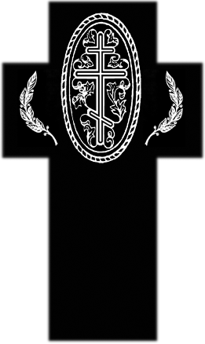  3  2  4  1  Рис. 4.8. Заготовка-крест. | To work with intricate-shaped workpieces do the following:  * Draw the mockup of your workpiece in Adobe Photoshop. You can make digital photo of your workpiece and use it as the Adobe Photoshop mockup. Using the Adobe Photoshop, place the image on the mockup in a desired position. Now open this picture in the Engrave.  * Find the start point (upper left corner of the picture – see item 2, Figure 4.8). The start point is located outside the limits of the workpiece. Red square (item 1) shows the image limits. Move the engraving tool to the start point 2.  * To make the moving of the tool to the start point more convenient, you may want to do the following:  - Fins the basic point on the workpiece, for example, the edge of the workpiece (item 4 on the Figure) and move the tool there.  - Measure the distance between the start point 2 to the basic point 4 on the picture. Say, this distance is 50 mm.
- Switch the Machine to Manual Mode by pressing <MAN> key. Press <CLR> key to reset current coordinates and, while in the Manual Mode, move the engraving tool by given distance. In our example we have to move by - 50 mm along X axis to move the tool from position 4 to position 2.
* Staying in the Manual Mode, lift the engraving tool, so as to position it above the workpiece surface. Start the engraving in the Engrave program. The Machine will set the gap and start the engraving from position 3, that is from the location, where the first row of the picture starts.

Engraving large-size images by parts
In this case you should divide your artwork into parts as may be necessary:
- You may want to make a composite picture, consisting of several smaller size tiles. In this case the machine should engrave each single tile from one edge to another edge with no margins.
- If you need to engrave the oversized picture, with sizes exceed the working area of the Machine. The question is, how to put separate parts of the workpiece together on the workpiece surface, and how to make the joints invisible.

Dividing oversized picture into parts
* Open your picture in Adobe Photoshop;
* User the command "Edit/Preferences/Guides and Grid…". In the "Gridline every" field set the size, multiple of the size of a single tile. For example, if your tile size is 20 x 30 cm, the grid step should be 10 cm. In the "Subdivisions" field set the value "1". Click "Ok";
* Now use the menu command "View/Show/Grid" so, that this menu point is checked. Grid with the given step will appear above the picture;
* Use the menu command "View/Snap to/Grid", so that this menu point is checked;
* Using the "Rectangular Marquee Tool", select exactly by the grid squares the fragment of your picture of the desired size. This is easy to do, when the "snap to grid" mode is on;
* Use the menu command "Edit/Copy" or "Edit/Copy Merged";
* Use the menu command "File/New…". In the "New" window click "Ok". The new picture will appear in the screen;
* Use the menu command "Edit/Paste" and save the fragment using the "File/Save" command. In the "Save As" window specify the name of your picture, say "01";
* Close the fragment-picture window;
* Using the "Rectangular Marquee Tool", select new fragments and save them as independent files, having named them "02", "03", etc.. Repeat the above steps, until the entire initial (large) picture is saved as fragment files;

Jointing separate picture-fragments on the Machine
- If you need to produce composite picture, each fragment-picture should be engraved on a separate tile. How to engrave tiles with no margins, see section 4.21.
- If the picture size on the workpiece exceeds the size of the workspace of the Machine, for example, if you have to engrave the full length portrait, do the following:
* Engrave the first fragment;
* Move the workpiece to the beginning of the non-engraved area;
* Moving the engraving tool along X axis in the Manual Mode lengthwise the edge of the already engraved fragment, adjust the Machine in parallel with the fragment;
* Open the second fragment-picture in the Engrave program;
* Switch the Machine to the Manual Mode by pressing <MAN> key and move the tool along X axis roughly to the beginning of picture (you won't be able to position the tool precisely at first attempt). Don't move the tool head along Y axis;
* In the Engrave program decrease the impact strength A2 and Аmax to the minimal values, so that the Machine doesn't engrave dots on the workpiece;
* Click "Start" button (green arrow) on the tool panel in the Engrave to start engraving. As soon as the Machine has started to engrave the first row, click "Pause" button. The engraving tool will reach the end of the row and stop. In the Engrave program stop the job by clicking "Stop" button in the "Pause" window;
* Make sure, that the engraving tool has stopped exactly on the edge of the previously made picture along X axis. Most likely, the tool hasn't stopped on the edge, but has shifted along X axis by some distance. Remember the value of this displacement to use it in the future correction;
* Enter the Manual Mode by pressing <MAN> key, lift the engraving tool by pressing <Z UP> key by 2..3 mm, and click <0> key to move the tool to the start point;
* In the Manual Mode move the engraving tool along X axis by the value of the aforementioned corrective displacement;
* Start engraving again, then stop it by pressing "Pause" button and check the X displacement. Repeat the above steps, till the Machine moves exactly to the edge of the picture along X axis. Usually it takes from two to three test passes to make the adjustments properly.
* In the Engrave program set the impact strength for A2 and Amax;
* Click "Start:" button on the Engrave tool panel (green arrow) and start engraving in a normal manner.

Engraving tiles with no edge indents
To make an engraving on a tile with no margins, or indents on its edges you need to replace the level sensor tip. The new tip must have a shape of a sewing machine presser with the engraving tool passing through its center hole. This type of sensor tip will not go off the edge of the workpiece even if there are no indents.
In case of zero indents the engraving tool must start operation from the tile corner. To set the gap do the following:
* In the Manual Mode move the tool to the tile corner;
* While still in the Manual Node, press <CLR> on the Control Unit to reset the coordinates;
* Move the engraving tool by 3…5 mm from the tile corner;
* Set the gap using the Machine's Control Unit by successively pressing <CLRN> and <ENTER> keys. The gap will be set automatically;
* Press <MAN> key and then <0> key. The machine will return its tool head to the initial point in the tile corner. Press <ESC> key.
* In the Engrave program, click "Start";
* In the "Move to start point" window uncheck the Auto clearance" checkbox and click "Start". After the tool has moved to the start point, "Set Z clearance" window will open. Click "Continue" to skip the gap setting step. In the Start work" window click "Yes". The Machine will start engraving.

Engraving rectangular fragments of picture
The Engrave program allows you to engrave the selected part of the image repeatedly.

Repeated engraving of rectangular fragment of a picture
* In the Engrave program use the mouse to select a rectangular fragment of picture;
* Size and location of the selected area may be adjusted by the mouse, while <Shift> key is pressed. Don’t cut the selected fragment;
* Start engraving by clicking the "Start" button (green arrow). The engraving tool will move from the left upper corner to the left upper corner of the selected area of the image. The Machine will engrave the selected fragment only.

This method is very useful for the engraving by parts: for example, to engrave only portrait, only text. You can set different engraving parameters for the portrait and for the text, for example, different impact strength values.
WARNING! When repeatedly engraving a rectangular fragment of the image, it will look lighter on the image, which is usually undesirable. Therefore, when engraving fragments of the image, use mask (see Section 4.23).

Engraving arbitrary-shape fragments. Image mask
The advantages of the use of masks in the Engrave program:
- You can select arbitrary-shaped (not necessarily rectangular) fragments for the repeated engraving, as well as several fragments at once;
- When repeatedly engraving the fragment you can make You can make smooth, imperceptible gradients. To make smooth gradient in Adobe Photoshop use the soft brush for the selecting of a fragment;
- In the Dot Mode the mutual layout of black and white dots will remain the same, irrespectively of whether the mask is on or off. This is important, since in case of the repeated engraving of a fragment when the mask is on, the clarity of picture caused by non-coincidence of dots will not deteriorate;
- Image mask is created in the Engrave program, and not in the third-party graphic editor, such as Adobe Photoshop. To create sophisticated mask contour you are free to use the whole range of the Adobe Photoshop tools – layers, soft and hard brushes, eraser, etc. The initial image and the mask are copied and pasted between the Adobe Photoshop and the Engrave using standard "Copy/Paste" (Ctrl-C/ Ctrl-V) feature.
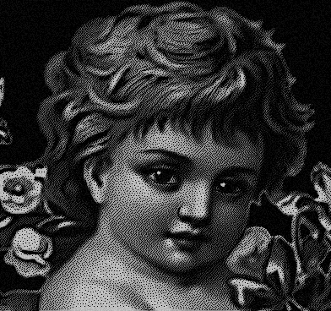 | 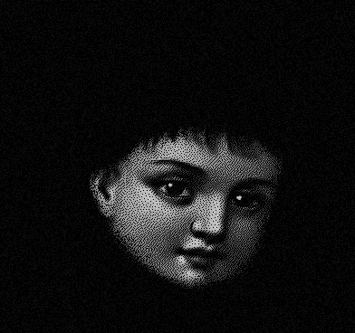 | 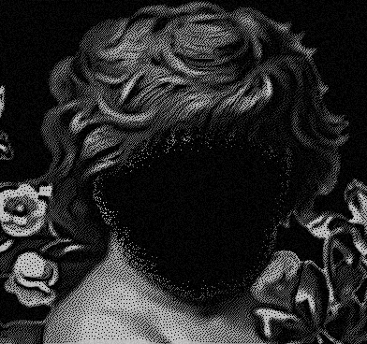
Figure 4.9.1: Initial image | Figure 4.9.2: Masked face | Figure 4.9.3: Inverted mask

Creating a mask
* In the Engrave program use the menu command "Edit/Copy", or press <Ctrl-C>. If a rectangular fragment is selected on the picture, you need to cancel the selection, as you need to copy the entire image;
* Now go to Adobe Photoshop;
* Use the menu command "File/New…", or press <Ctl-N>. Click "ОК". The new window with the same size, that the initial image will appear;
* Use the menu command "Edit/Paste", or press <Ctl-V>. The image, copied in the Engrave, will be pasted to the Photoshop;
* Create new layer by suing "Layer/New/Layer…" command, or by pressing <Ctrl-Shift-N> key combination;
* Select "Brush tool" from the tool bar, set black foreground;
* Adjust brush type and size (use <[> and <]> keys). You want to use soft brush, in this case the masked fragment will have smooth edges in the Engrave, and during the repeated engraving the edges will be imperceptible;
* Paint black the background, that you don’t need. For creating backgrounds it is also convenient to use "Pencil Tool", "Paint Bucket Tool" and the soft edge "Eraser Tool" for the deleting of unwanted background;
* Select the entire image by using the command "Select/All" or by pressing <Ctrl-A>. Copy the picture using the "Edit/Copy Merged" menu command, or by pressing <Ctrl-Shift-C>;
* Now go to the Engrave;
* Apply the menu command "Edit/Paste image mask", or press <Ctrl-Shift-V>. The mask, shown on Figure 4.9.2, will appear on the screen;
* If you need to modify the mask, go back to Adobe Photoshopи and make necessary changes. Having that done, copy the image using "Edit/Copy Merged" command and in the Engrave paste the modified mask using "Edit/Paste image mask" command.

Working with the mask in the Engrave
* Switch the mask on and off: use the menu command "View/View image mask", or click the tool panel button with the "eye" symbol. When the mask is off, the Machine will engrave the selected fragment only. When the mask is on, the Machine will engrave the entire image;
* The menu command Image/Invert image mask (Ctrl-Shift-I)" inverts the mask, as shown on Figure 4.9.3;
* The menu command "Image/Save image mask (Ctrl-Shift-S)" saves the mask in "Windows BMP" file. You can specify the name of and the pass to this file in respective dialog window;
* The menu command "Image/Open image mask (Ctrl-Shift-O)" opens image mask, which has been previously saved as the "Windows BMP" file. You need to specify the name of and the pass to this file in respective dialog window. Width and height of the mask, saved in the separate file, must match the width and the height of your image;
* When the mask is opened, you may not use the editing commands, such as change image size, rotate. You also may not enjoy the Stone Layout Mode (<F8>).
* To delete the mask use "Image/Close image mask (Ctrl-Shift-D)" command.

The use of the image mask is recommended in the following cases:
1. To shorten the engraving time and to reduce the engraving tool wear and tear when engraving a portrait against the background. You should select the mode, where the portrait faces are engraved in HQ mode (that is in two passes), while the background is engraved in one pass.
You should do the following:
- Use image mask to select faces in Adobe Photoshop (Figure 4.9.2);
- Copy the mask from Adobe Photoshop to Engrave;
- Turn on the "HQ" mode on the tool panel of the Engrave;
- Check the "Second pass" and "Mask" checkboxes in the information panel of the Engrave (item 7, Figure 3.3);
- Start engraving. The Machine will engrave the entire image on the first pass (Figure 4.9.1), and on the second pass the Machine will engrave faces only (Figure 4.9.2).

2. To prolong service life of engraving needles, when engraving portrait against the background. Use mask to select faces and other fragments, which require higher engraving quality. These fragments should be engraved using new (sharp) engraving needle. Thereafter you may use the older (worn) needle to engrave the reminder background.
Do the following:
- Select faces, using the mask in Adobe Photoshop;
- Copy and paste the mask from Adobe Photoshopв to Engrave;
- Install the new needle. Turn on the mask (Figure 4.9.2) and engrave the faces only. Upon completion of the engraving job the machine will move tool head to the start point;
- Now replace the needle with the older one;
- In the Engrave program use the menu command "Image/Invert image mask (Ctrl-Shift-I)". The whole image except the face will be masked (Figure 4.9.3);
- Start engraving. Background will be engraved using the older (worn) needle.

Selecting the specific halftones
The Engrave program allows you to highlight in color the specific halftones on the picture. Color highlighting allows you to analyze which halftones are presented or missing on the image. This in turn allows you to check the retouching quality and understand, to what part of the image the preset strength of impact corresponds on the amplitude graph.
* Use the menu command "View/View halftones" to switch the halftone highlighting mode on/off. If the mode is on, the menu point is checked.
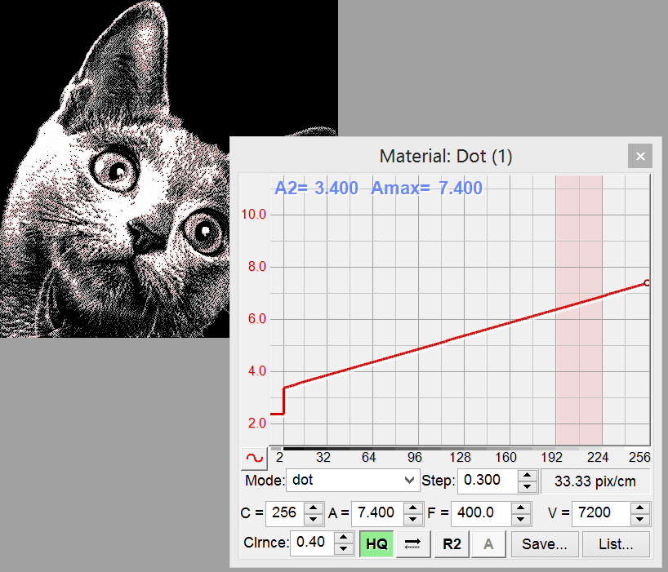  Figure 4.10: Highlighting halftones in color | * To select the halftone press and hold <Shift> key on your keyboard. Select the desired halftones by left-clicking on the amplitude graph in the "Material" panel.  * When clicking the mouse on the amplitude graph, the four-halftone region is highlighted, for example, from 1st to 4th, from 16th to 20th, etc. You can also highlight several regions, both adjacent and spaced-apart. To cancel the selection, left-click the selected range again.
* Selecting the region consisting of several halftones. While holding <Shift> key pressed, left-click the mouse on the amplitude graph on the non-highlighted halftone. While holding the left mouse button clicked, move cursor to the left or to the right within the graph. Adjacent halftones will be highlighted;
* To cancel the selection do the same things, but left-click the mouse on the highlighted (red) halftone;
* Together with the highlighting of the selected graph region in red, the respective areas of the image, corresponding to the selected halftone range, will be highlighted on the image;
* To switch off the halftone highlighting mode use the menu command "View/View halftones".

Engraving the selected halftones
The machine is capable to engrave only the halftones, highlighted on the amplitude graph.
* To engrave in this mode you need:
1. To switch the halftone viewing mode using the menu command "View/View halftones". Respective menu point must be checked;
2. Highlight the desired halftones on the graph (see the section above);
3. Turn on the halftone engraving mode using the menu command "Mode/Engrave selected halftones". Respective menu point must be checked;
4. Click "Start" button. The Machine will start engraving only the areas, corresponding to the highlighted halftones;
* To cancel the engraving mode and viewing the highlighted halftones:
First alternative. Switch on the viewing mode using the menu command "View/View halftones". Uncheck the respective checkbox.
Second alternative. Deselect all the highlighted regions on the amplitude graph.
* If need only to view the highlighted halftones without the engraving, you should switch off the highlighted halftones engraving mode by unchecking the "Mode/Engrave selected halftones" checkbox. Check "View/View halftones" point in the menu.

Nonlinear adjustment of strength of the impact
The amplitude graph, accessible in the "Material" panel, determines the dependence between the strength or the amplitude of the impact and the brightness of a single dot halftone. Nonlinear adjustment of the amplitude graph ensures more precise dithering during the engraving process.
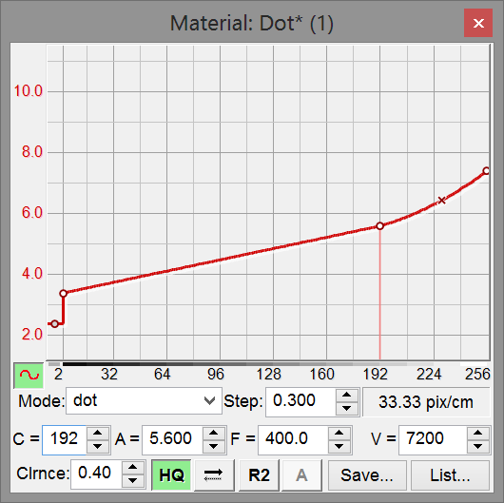  6  5  7  1  3  4  2  Figure 4.11: Nonlinear impact strength adjustment | - Amplitude graph edit button;  - Current color, where 1 = black and 256 = white;  - Current amplitude value for the current color, item 2;  - Insert-move node indicator;  - Node point of the graph;  - Graph flex point;.  - Mark of the point, selected for editing..
* To switch on the amplitude graph editing mode click button 1. To quit the amplitude graph editing mode click button 1 once again. You can edit the amplitude graph even when the engraving is in progress.
* Inclination of specific segments of the graph is adjusted by the node points (item 5). Curvature of specific segment of the graph is adjusted by the graph flex points (item 6). You can set up to 10 node point on the graph. You may additionally set flex points for each single node.

Adding new node point
- Move the mouse cursor to the desired point on the graph. Indicator (item 4) should turn green;
- Click left mouse button. The new node point marked with the white circle will appear on the graph;

Setting flex point
- Press and hold <Ctrl> key;
- Move the mouse cursor to the desired point on the amplitude graph. Indicator (item 4) should turn green;
- Click left mouse button. The new flex point marked with the cross will appear on the graph;

Moving node or flex point using the mouse
- Move the mouse cursor to the desired node point or flex point. Indicator (item 4) should turn red;
- Left-click and drug the mouse, thus moving the selected node/flex point to the new location;

Deleting node or flex point
- While holding left mouse button, move the desired node/flex point outside the limits of the amplitude graph window, then release the mouse button;
- Node point for the values C = 1, 2, 256 cannot be deleted.

Precise adjustment of the amplitude value for the node/flex point
- Select the node point you want to modify by left-clicking in the field “C =” (item 2). While holding <Ctrl> key, press <UP>/<DOWN> arrow keys on your keyboard. The values of the respective colors for the existing node/flex points will be displayed in ascending/descending order in the field “C =” (item 2). The selected point will be marked with the red line on the graph (see item 7);
- To change the amplitude value for the selected node point go to field "А=" (item 3) by left-clicking mouse inside the field. Use <UP>/<DOWN> arrow keys to increase/decrease the value А. The selected node will respectively move up or down on the graph.

Engraving deep letterings using high impact strength values
You may increase the strength of the impact by increasing the gap. In so doing you should at the same time increase the impact strength value. Remember, that the stronger is the impact, the greater is the tool's wear and tear.
* This method of engraving is applicable to the images with no halftones, that is black and white images, such as a lettering;
* In the "Material" panel increase the gap value approximately up to 0.50..60 mm. Impact strength Amax (C=256) for whites must be increased. Save the material, having specified file name, by clicking "Save…" button in the "Material" panel.

Engraving on vertical surface
You can use the Machine for making engravings ob vertical surfaces. However, you should first switch the Machine into the Vertical Engraving Mode. To switch this Mode on and off, use the "Mode/Engrave on vertical surface" menu command in the Engrave program, while the Machine is on. In the Vertical Engraving Mode the stepper motors may produce light noise in the idle mode.

Creating test color wedge
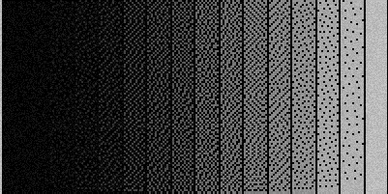 | For the testing and adjustment of the Machine the engraving of the test color wedge is used (see Figure4.12). Color Wedge is a great tool in checking and adjusting the Machine's ability to engrave separate halftones.
Figure 4.12: Test Color Wedge

To engrave the test wedge in the Engrave program:
* Use the menu command "Image/Make halftone gradient…";
* In the "Make halftone gradient" set width and height of your test wedge in millimeters. In creating the test color wedge the then current engraving step, set in the "Material" panel will be used;
* You need to set any additional parameters you can:
- Set the number of halftones from 2 to 256;
- Define, where the black color will appear: on the left, or on the right;
- Skipped interval width in dots, that is the width of the black line, splitting different halftones from each other. If you don't want this line to appear, set the value to zero;
- Edge line: defines whether or not the Machine will engrave the white vertical border line on the edge of the black color;
* Click "OK". Wedge picture will appear in the Engrave window. Proceed with this picture, just like it's a usual image.

Creating shortcut for viewing the image during the engraving
To control the quality of your image before you start the engraving process, you need to open the image in the Engrave. It often happens, that while you are engraving one picture, you are at the same time retouching another picture in Adobe Photoshop on the same computer. If this is the case, the Engrave is already busy and you won't be able to open a new picture before the current engraving job is done.
To resolve this problem use the Engrave menu command "File/Create view shortcut…". Additional shortcut with zero number will be created on your desktop. The Engrave, launched using this zero shortcut, will work independently of other copies of the program, launched using the shortcuts number 1, 2, etc. This copy is intended for viewing images only, and not for engraving tasks.

Job log
The Engrave program maintains the runtime log, where it records all the completed jobs. Using this log you can control the number of completed jobs. This log cannot be edited. All the completed jobs are registered in the log automatically.
* To view the log of jobs use the menu command "Work/Work List…". The "Work List" window will be opened with the list of jobs, sorted in the order of completion. The last completed job is the last in the list.
* To create printable text document with the job log click the "Report" button. The log will be saved in the file named "lst80aXX.txt", where ХХ is the Machine number. The file will be saved in the Engrave folder.

Details of each job include:
- Date and runtime;
- Time of beginning and time of completing the job;
- Exit code - that is successfully finished, interrupted, error while in progress, paused and resumed after switching off;
- Progress indicator, where 100% means that the engraving job was successfully completed;
- Image area in sq. cm;
- Engraving step (item 4, Figure 3.4) and the respective material name (item 17, Figure 3.4).

Installing the Software

Installing the Engrave software
* Connect the Machine and the PC with the communication cable (USB);
* Plug power cables of the Machine and the PC to mains sockets;
* Power on the Machine. Menu command "1. Manual movement" should appear on the control panel display of the Machine.

WARNING! Engrave is intended for operation under WindowsXPSP3, Windows Vista, Windows 7 and Windows 8. If your PC runs under Windows XP SP1 or SP2, you should upgrade your Operating System to SP3. Instructions and the upgrade package are available at Microsoft web site.

Installation
* Use "Windows Explorer" to copy the Engrave 8 folder from the Installation CD to your hard drive, for example to "C:\";
* Go to your "С:\" hard drive and open the "Engrave 8" folder. Launch the Engrave application.
* "Scan for machines" window will appear on the screen. If this didn't happen, use the menu command "File/Scan for machines…" from the Engrave program;
* Follow the instructions of the Engrave program and set up the Machine. Make sure, that the Machine is connected to your PC via USB cable. The Machined must be turned on. In the "Scan for machines" window click the "Continue" button. If the Program has found the Machine, in the "Machine" column of the "Scan for machines" window you will see the message, confirming that the Machine is found, an displaying the Machine's number. Click the "Continue" button again. The Engrave will create shortcut on your desktop. Then click "Exit" to close the program;
* Find the "Engrave" shortcut on your Windows desktop. Thereafter always launch the Engrave program using this shortcut.
* If the Engrave program has failed to find a machine, turn the machine off and check, whether it is properly connected to the PC. We recommend to disconnect both ends of the cable and connect the machine and the PC again. Having that done, use the menu command "File/Scan for machines…" and repeat the search.

Working with several machines from a single PC
* Connect the machines to free USB ports of your PC;
* Turn on the machines. "1. Manual movement" message should appear on the control units screens of all the connected machines. Using the Engrave, launch automatic hardware search, using the menu command "File/Scan for machines…".
* When the search is over, the Engrave will be closed, and separate shortcuts named "Engrave8.0 (1)", "Engrave8.0 (2)", etc. for each of the machines will appear on your Windows desktop. Figure within the brackets means the number of respective port, so the figures may appear not in the regular order;
* Each shortcut opens separate copy of the Engrave program. Each copy controls its own machine.

Maintenance

Replacing the engraving tool (needle)
Frequency: in view of the actual wear
Determining the needle wear must be carried out using the wear and tear control system (see Section 11).
For needle replacement procedure see section 3.2.

Replacement of the level sensor sensitive element
Frequency: in view of the actual wear
The sensing element must be replaced in case of severe wear. Round head screw may be used. For the sensitive element replacement procedure see Section 8.3.

Lubricating the guides of X, Y, Z drives
Frequency: once a week
* To lubricate the guides, moisten clean piece of textile with household grade machine oil (liquid) and rub the guides (see Figure 6.1).
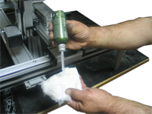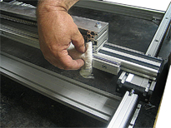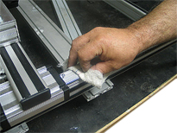
Figure 6.1: Lubricating the guides
* Lubricate X, Y, Z screw drives (Figure 6.2) in two or three pints, distributed longwise the screw, with household grade machine oil (liquid). Switch on the Manual Mode and move the head along X, Y, Z axis for the whole stroke, so that the oil is evenly distributed over the contact surfaces of screw drives and nuts.
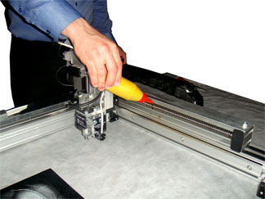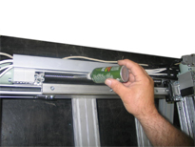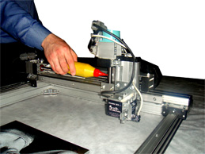
Figure 6.2: Lubricating X, Y, Z screw drives

* Don't apply excessive amount of oil onto the screws, cause this will result in dust deposition and even more severe contamination.

Troubleshooting

WARNING! In case of any failures, please, follow the recommendations of this Chapter. If carrying out of these recommendations has not resulted in solving the problem, or if you have any doubts, please, contact our service department. Our consultants will assist you in identifying the reasons of failures and troubleshooting. Don’t follow the advises of unauthorized persons.

Depending on the nature of specific repair, needed for your engraving machine, and depending on whether or not you have proper repairing facilities, the machine may be repaired on-site, or at the manufacturer's facilities, or at the facilities of the manufacturer's local dealers.

Most of the damages are caused by non-observance by the users of operating conditions, including admissible run time, failure to lubricate the machine, poor maintenance, failure to observe rated operating conditions.
Possible damages of engraving machines include mechanical and electrical ones.
Mechanical damages may in particular include:
- wear of support bearing of X, Y, Z drives, impact magnet and level sensor;
- wear of bearings and ball-bearing pairs;
- loosening of couplers, wear of the coupler "core";
- loosening of motor mounts, impact magnet and level sensor components.
Electrical damages most commonly include:
- loss and damaging of soldered contacts, inadmissible deterioration of insulation resistance caused by aging, damaging, damping;
- break of conductors in X, Y, Z, R, M cables;
- overheating of amplifiers of the control board, or damaging of chips and other electronic components.

Failures and damages of the engraving machine are far not always identifiable by means of visual inspection, as some of these failures and damages (break of cable conductors, faulty electronic components) are hidden and cannot be found without specific measurements and tests.

Troubles when switching on the Machine

Control Unit display does not turn on
* If Power Supply Unit cooler is off:
- Check, whether the power supply unit on/off button on the rear wall is in the right position. Check contact of the on/off button on front panel of Control Unit. Replace faulty button if necessary. If the button is OK, replace Power Supply Unit.
* If Power Supply Unit cooler is on:
- Open Control Unit, check connection of the flat cable to the socket on the control board (item10, Figure 9.1).
- Press <MAN> button on the Machine's Control Panel. Try to move the tool "blindly", using the X, Y, Z coordinates arrow keys. If the tool moves, adjust the highlight trimming resistor on the control board (item 16, Figure 9.1). Turn the Machine off, adjust the resistor with the thin-tip screw driver. Display screen brightness will change.

Manual Mode
Hindered movements of carriage along X/Y/Z axes. When operated by hand, the loud noise is heard.
- Ball screw drives and carriages are clogged with dust and dirt or have no oil. Clean and lubricate ball screw drives and carriages (see Section 6.3).
- Control board failure. Contact service center.

Manual movement along one of the axes X/Y/Z doesn't work or the movement is possible in one direction only.
- Check performance of the end switches (see Section 8.5);
- Improper operation of the X/Y/Z drive. For checking the drives, see section 8.4.

When pressing arrow-key the tool head moves in reverse direction, for example, the tool moves up along Z axis instead of the moving down.
- Break or short-circuit in the wire connecting Control Unit with the respective drive, usually in Z or X cable. Replace the wire. For wire replacement procedure, see Section 9.5.
- Failure of the amplifier chip on control board. Contact service center.

On Y axis the tool head has "snapped" to the end switch
- When moving the tool head along Y axis the end switch triggers, but the tool head does not move in reverse direction;
- Change settings. In the Engrave use the menu command "File/Options…" to open "Options" window. In the "End switch Y" list-box change the value to the opposite, that is type "Y1" instead of "Y0". Turn on the Machine. In the Engrave program open "Options" window and click "Write to machine" button.

Launching the Engrave program

After you have attempted to launch the Engrave program the following error message is displayed: "Can no find entry point in dynamic link library…".
The Engrave runs under Windows OS. The oldest admissible Windows version is Windows XP SP3. If you operate versions Windows XP SP1 or SP2, you need to upgrade to SP3.

Starting engraving an image ("Start" command)

"Communication error" message is displayed in Engrave:
- Check USB cable, connecting the Machine to your PC, and check USB flat cable inside Control Unit (item 18, Figure 9.1);
- Check, whether or not the machine operates with another PC. It is possible, that the PC is faulty.

Error # 1: "End switch X0|X1|Y0|Y1|Z0" is displayed both in the Engrave and on the Control Panel
- Before you start operation in the manual Mode, move the tool head away from the end switches. Make sure, that while in the manual Mode, neither of the following symbols is displayed in the lower left corner of the screen: "X0"/ "X1"/ "Y0"/ "Y1"/ "Z0". If any of the end switch indicators is on, even when the tool head is in the center of the work field, check the end switches (see Section 8.5).

Possible error messages, if automatic gap setting is selected:
- "Error 3/xx.R sensor fault"
- "Error4/xx. T sensor fault"
- "Error5. Magnet moves up"
- "Error6. Magnet impact is weak"
- "Error8. R sensor is too low"
- "Error9. R sensor too close to tip"
- "Error10. Z move limit too small"
- "Error12. No touch".
- "Error15. R value unstable".
- "Error18. Magnet – no impact"
Foe possible reasons and error curing methods, see Section 7.12.

The needles moves heavily up or down (curs the stone) in the beginning of a job, right on the first row.
- Check the level sensor and the R wire, see Section 8.3.

The machine stops during the engraving, although the job is not completed yet

In the course of engraving (when the operator is away) the Engrave program is quitted. After the repeated launch the Engrave offers to resume the job.
- You PC goes to sleep mode. This happens, when the operator does not perform any actions with the PC. To ensure proper operation of the engraving machine, turn off the sleep mode. In Windows control panel select "Power Options". Disable sleep mode in current Windows power scheme.

Multiple communication errors during the work. In the course of engraving the "Connection error" window periodically appears and goes off, however the Machine proceeds the engraving.
- Improper PC and machine grounding (see Section1.3);
- Try to run the Machine with another PC. If the problem is solved, the trouble has to do with the PC hardware or software;
- If the machine is connected to the PC though COM port directly, you need to use COM-USB adaptor;
- If the PC is connected to the machine through COM-USB adaptor, the particular model or the particular adaptor may be unsuitable. To ensure trouble-free operation using COM-USB adaptor, use the products, recommended by SAUNO.

Engrave Error #7: "Level changed greatly" is displayed both in the Engrave and on the Control Units display
For details see Section 7.12.

The Machine does not stop, when the tool leaves the workpiece area (error #7).
- Too small distance from the needle nib to the tip of the level sensor. Adjust level sensor (see Section 9.10).

The Machines stops, "Manual movement" is displayed on the control panel. After having switched to the Manual Mode, the values of X, Y, Z coordinates equal 0. It is impossible to resume the job from the point of interruption
- Wires short-circuit. Replace Z and/or M wires (see Section 9.5).
- X wire short-circuit. Replace X wire (see Section 9.5).
- Faulty power switch button on the front panel of the Machine's Control Unit. Replace the button.
- Power Supply Unit failure. Replace Power Supply Unit (see Section 9.3).

Distortion of the image in the course of engraving

The Machine has engraved an image fragment and moved to another position
Cell Mode is on in the Engrave program. This is not an error. The Engrave software engraves your picture by parts in order to avoid idle passes over black background and to shorten the execution time. Switch off this mode by using the Engrave menu command "Mode/Cell mode". For details, see Section 4.10.

The image is stepwise shifting along X axis
The Machine sticks and stops before reaching the end of the row, and then starts engraving the next row in reverse order, thus producing the stepwise shift.
Possible reasons:
- Break of wire X. Replace the wire. For wire replacement procedure, see Section 9.5.
- Faulty X drive motor or the X drive itself. See Section 8.4 for details on checking the drive mechanics.
- Faulty control board or power supply unit. Contact service center.

The image is gradually shifting along X axis
- Check the X motor coupler (item 5, Figure 9.4). Tighten two screws on two half-pieces of cylindrical part of the coupler;
- Make sure, that the grounding is made properly (see Section 2.3).

The image is vertically shrunk (in the Y axis)
- In the Engrave program uncheck the menu "Mode/Work on cylinder";
- Check the tightness of screws on the Y motor coupler (item 5, Figure 9.4). Check tightness of screws on two half-pieces of cylindrical part of the coupler;.
- Make sure, that the Y step value in the "Options" window in the Engrave is set properly. Modify the step as appropriate (see Section 5.3).

Picture size on the stone does not comply with the picture size in the Engrave
- Check, whether the X and Y steps in the "Options" window in the Engrave match. Modify the step as appropriate (see Section 5.3).

When making idle pass along Y axis (for example, when moving between text rows), the tool moves by a lesser distance than it should
In the Cell Mode the image fragments shift along the X or Y axes. Upon completion of the job the machine return the tool head back to the start point with some offset.
- Decrease idle speed in the respective axis (X or Y). In the Engrave use the menu command "File/Options", in the "Options" window click the "Velocities" button, then in the "Velocities" window decrease the "X/Y fast" value roughly by 1.5..2 times (for example, enter 2000 instead of 4000). In the "Velocities" window click "Ок", and in the "Options" window click the "Write to machine" button and then the "Ок" button.

Magnet does not produce impacts

The tool keeps moving moves, but does not hit the stone
- In the Engrave check the Amax value. As a check, set Amax=8.000;
- Switch on the "Test magnet" mode on the machine's control panel and check, whether the magnet vibrates (see Section 8.1). If there are no magnet vibrations even at larger amplitude values (А=8.000 as a check), then check the M wire contact and the magnet connector on control board (item 8, Figure 9.1). Make sure, that the M wire tightly seats in the connector on the control board. Replace M wire.

Some image fragments remain blank
- Replace magnet drive M. For replacement procedure details, see Section9.5.

Horizontal stripes across the image in the X axis

Several millimeter or centimeter width stripes appear on the image. The stripes are sometimes brighter, sometime darker
- Check, whether the grounding is correct (see Section 2.3);
- Check level sensor for mechanical failures. For details, see Section 8.3;
- If the machine is operated for more than a year, it’s time to replace the Z, R, M drives. For replacement details, see Section 9.5;
- Adjust the magnet. For details, see Section 8.2;

Vertical stripes across the image in the Y axis

Vertical stripes, or equidistant brightness variations (approximately 10 mm step)
The problem is in the X-drive motor mounting unit.
- Loosen but do not fully release, the X-motor mounting screws (item 3, Figure 9.4);
- By rapidly moving tool head in the X-axis in the fast movement control mode, check, in there a bouncing in the X motor;
- If there is a bouncing, adjust coupler (item 5, Figure 9.4) bouncing. Remove the motor and reposition the coupler half-pieces. Experimentally find the position, where the bouncing is minimal;
- Adjust positioning of the motor mounting "sleeve" holes as appropriate (item 6 , Figure 9.4);
- Switch on X drive in the manual control mode and make the carriage move along the entire length, while tightening the screws (item 3, Figure 9.4). Tighten the screws in diagonal order to avoid skewing in respect to the driving screw;
- If the problem persists, contact service center.

Engraving quality problems

The engraved image is hazy, gray, "noisy". Poor halftones, excessive contrast, blacks instead of grays

The engraved image is too light, flat, too dark or excessively contrast. Poor gray halftones
1. First you need to understand, whether it is a problem of the image retouching, or the problem of the Machine:
- Install new needle;
- Engrave test picture, for example, the picture of eyes from the Engrave installation CD (see Figure 1.7). If the test image is engraved well enough, then the problem is dealt with excessively worn needle or the improper retouching in the Photoshop;
- If the problem is dealt with improper retouching, you may want to enjoy the retouching services offered by SAUNO Retouching Center. Find contact details on our web site.
2. Make sure that the ground is made properly (see Section 2.3)
3. Level sensor problem:
- Check level sensor for mechanical damages, check level sensor readings (see Section8.3);
- Check Z drive (see Section 8.4). The crew must rotate with even torque and with no jamming.
4. Magnet problem:
- Check, whether the impact strength (amplitude) in the Engrave program is set correctly. Set standard values A2 = 4.000, Amax = 8.000. Engrave the test eyes image (see Figure 3.5). If the Machine fails to reproduce dark dots, increase the A2 value, till the dots turn gray. If the impact strength is too weak (dark image), gradually increase the Amax value. If the impact strength is excessive (too bright image), decrease the Amax value.
- If the impact strength (amplitude) adjustment give no desired results, adjust magnet (see Section 8.2).

Image retouching problem

In engraving the letterings the letter edges are not clear (In the Engrave preview and on the stone)
- When creating the lettering in Adobe Photoshopна use "Character" panel to select "No" in the "Set the anti-aliasing method" (see Section 10.21).
- Don't change image size in the Engrave. Always create fixed-size workpiece mockups in Adobe Photoshop.

In the Engrave program grey dots appear against black background around a portrait
- Open your image in Adobe Photoshop. Use the menu command "Layer/Flatten Image";
- Select "Brush Tool" from the tool panel. Set black foreground;
- Check that the foreground is really black: it is sufficient simply to set the default foreground and background colors by clicking small icon to the left from and below the color selection icon;
- Make sure, that the "Opacity" = 100% in the brush settings;
- Using the brush, paint the black background around the portrait.

List of the Machine's error codes

"Error 1.End switchX0/X1/Y0/Y1/Z0"
Too head has touched one of the end switches in the course of engraving.
* If the error has occurred in the beginning of the engraving:
a) Before you start to engrave, make sure, that the engraving head does not touch the end switches: switch to the Manual Mode and move the head away from the end switches;
b) If the "end switch touch" message is constantly displayed on the control panel screen in the manual mode (one of the message: X0/X1/Y0/Y1/Z0 in the lower right corner), the end switch might be defective. See Section 8.5 for details;
* If the error has occurred while the engraving was in progress:
a) Image size exceeds the work field of the Machine. Use the Engrave to reduce the image size and the intends from the stone edges. Select correct start point for the engraving;
b) X or Y coordinates stick in the course of engraving; this results in shifting of the image. See Section 8.4 for details.

"Error3/xx. R sensor fault",

"Error4/xx. T sensor fault"
where xx = 01..09 is the extension code, such as "Error 3/01".
Possible causes:
a) Poor contact in R wire. Check the following connectors:
- R wire – level sensor on the tool head;
- R wire – R connector on the rear wall of the Control Unit;
- R flat cable –R connector on the print board inside the Control Unit (item 7, Figure 9.1);
Clean the connector terminals with pure alcohol. Tighten both lock crews after the connector is plugged-in;
b) R wire break/short-circuit. Replace the R wire;
c) Faulty level sensor R or touch sensor T. Contact service sensor and report:
- error code, including the extension code;
- when did the error occur: when setting the gap, when engraving, etc.

"Error 5. Magnet moves up"
The error occurs when setting the gap.
The magnet stick upward. Wrong magnet wire connection on the control board. Switch off the Machine, open the Control Unit, turn magnet wire on the control board (item 8, Figure 9.1) by 180 degrees.

"Error 6. Magnet impact is weak"

"Error 18. Magnet – no impact"
The error occurs when setting the gap.
Magnet impact strength is insufficient. Enter "Test magnet" menu on the control panel. Make sure, that the frequency F = 80.0, A = 7.000. Press <ENTER> to run the test.
a) If magnet vibrations are weak (D value on the screen is less than 10), the problem may be in poor contact of the magnet connector on the control board (item 8, Figure 9.1). Turn off the unit, check the contact, turn on the unit, repeat magnet test. If magnet vibrations are still weak, adjust the magnet. For details see Section 8.2.
b) If the magnet does not vibrate, check the following connectors:
- M wire М – magnet wire on the tool head;
- M wire – M connector on the rear wall of the Control Unit;
- M flat cable – magnet connector on the print board inside the Control Unit (item 8, Figure 9.1).
Clean contacts with pure alcohol. Tighten both lock crews after the connector is plugged-in.
Possibly the M wire break/short-circuit. Replace the M wire.

"Error 7. Level changed greatly"
The error occurs in the course of engraving.
a) The needle has went beyond the workpiece limits, emergency stop has occurred. This is not the fault. Wrong settings of the image width or the intends from the stone edges in the Engrave. Another possible reason is the image shift due to the X-drive mistake. See section 7.6.
b) The error occurs when the work is in progress and the tool head meets no obstacles.
- The operator has accidentally touched the level sensor tip, for example, when removing dust from the workpiece surface. This is not the fault.
- The sensor has caught on the unevenness on the stone. Be careful - deep irregularities (holes, dents) may damage the sensor;
- Check the level sensor. For details see Section 8.3. Insufficient tension of the sensor spring (see item 8, Figure 8.3). Another reason is the heavy wear of sensing element of the sensor (item 4, Figure 8.3). Replacement is required (for details see Section 6.2).

"Error 8. R sensor is too low"

"Error 9. R sensor too close to tip"
The error occurs when setting the gap.
When installing the needle, the bolt (ball) on the level sensor's presser should be positioned 2..3 mm lower than the needle tip, as the red arrows show on Figure 7.1.
- Error 8 occurs, when the level sensor presser R is positioned to close to the needle. Raise the level sensor.
- Error 9 occurs, when the level sensor presser R is positioned at the same level with the needle. Lower the sensor.

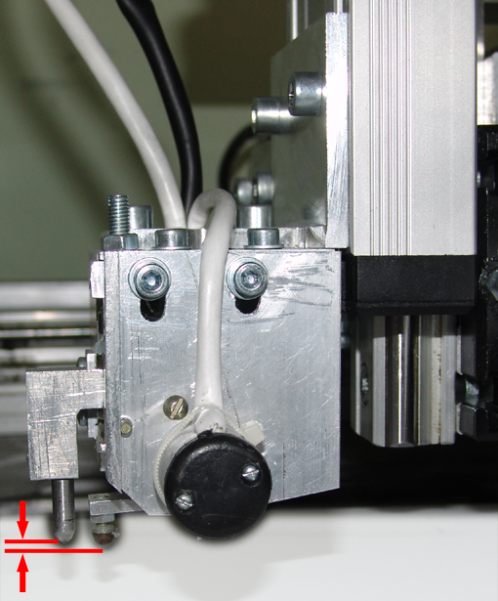  2..3 mm  2  1  Figure 7.1: Adjusting the level sensor height | - Level sensor;  - Level sensor height adjustment screws  To adjust the level sensor height, move the level sensor (item 1, Figure 7.1) up of down, having loosen the screws 2. After you have adjusted the sensor height, tighten the screws 2. While adjusting the sensor height, please, pay special attention, that in the working position, when the gap is already set, the level sensor presser must not catch on the needle. The distance between the sensor presser and the needle is adjusted be screws 3.  - If Error 8 occurs, while the tool head is moving down "in the free space" (that is when the needle has not yet touched the stone), check the level sensor spring tension. If the spring has "weakened" re-tense it.

"Error 10.Z move limit too small"
The error occurs when setting the gap.
Cause for the Error: vertical free travel allowance in the Z axis from the end switch to the stone surface is too small. You need to elevate the machine higher above the workpiece, for example, by placing timber pieces under the machine's legs, so as to ensure some free travel allowance in the Z axis.

"Error12. No touch"
The error occurs when setting the gap.
Having moved down the needle hasn't touched the workpiece surface. This may happen, when the workpiece is positioned too low. You need to lower the Machine or raise the workpiece. You may also move the tool head, having loosened set screws 11, Figure 9.6.

"Error15. R value unstable"
The error occurs when setting the gap.
Immediately after the gap has been set, the system measures and stores basic reading of the level sensor R. If this value has considerably changed, an error message will be generated. Causes for the Error:
- Either the workpiece, or the table has reeled at the moment of the measurement. This is not the fault. This may happen, if, for example, somebody has leaned the Machi9ne while the gap setting was in progress.
- Faulty level sensor R. Contact service center.

Other errors.
Control Board diagnosis software messages. Contact service center.

Checking and adjusting the machine components

Diagnosing and adjusting multifunctional impact head
Before you start the engraving work, you should, while setting the gap, check the performance of magnet, touch and tool movement control sensor (T) and level control sensor (R).
Possible errors:
- "Error 3/xx. R sensor fault"
- "Error 4/xx. T sensor fault"
- "Error 5. Magnet moves up"
- "Error 6. Magnet impact is weak"
- "Error 8. R sensor is too low"
- "Error 9. R sensor too close to tip"
- "Error 10. Z move limit too small"
- "Error 12. No touch".
Causes and error elimination methods are set forth in section 7.12.

Magnet adjustment mode
Magnet adjustment mode is used for checking of the engraving tool impact strength and considerably simplifies the adjustment process.
While in the test mode, the Machine control system measures the engraving tool oscillation amplitude and displays it in the Engrave as a graph. The system measures not only the magnet input oscillation amplitude, but the real oscillation magnitude using the special sensor, which enables precise adjustment of the impact strength.

Magnet adjustment procedure
* Turn on the machine;
* In the manual Mode, lift the engraving tool up, so that it does not touch the workpiece surface;
* The engraving needle must be installed;
* In the Engrave program use the menu command "Service/Magnet test…". The magnet will start vibrating, "Test magnet" mode notification will appear in the control panel display, and the "Magnet test" window with the tool oscillation graph will be opened in the Engrave (see Figure 8.2);
* In the "Test magnet" mode recommended values F = 80.0, A = 7.000 must be entered from control panel. If you were working with other values, please, enter the aforementioned values;
* Changing F and A values from control panel:
- In the main menu use <Y RIGHT> key to select the menu point "Test magnet". Press <ENTER>;
- In the "Test magnet" mode press <Y RIGHT> to select the parameter A (impact strength); the number to the right from "A" letter should blink. Press <X UP>, <X DOWN> keys to set the required value of the parameter A. To enter the fast value change mode press "F/S" button: "+" symbol will appear on the control panel screen;.
- To change the value of F (frequency), press "Y LEFT", then using <X UP>, <X DOWN> key set the desired value for F;
- Press <SAVE> to save the settings. You can change both the impact strength and the frequency right in the course of the test.

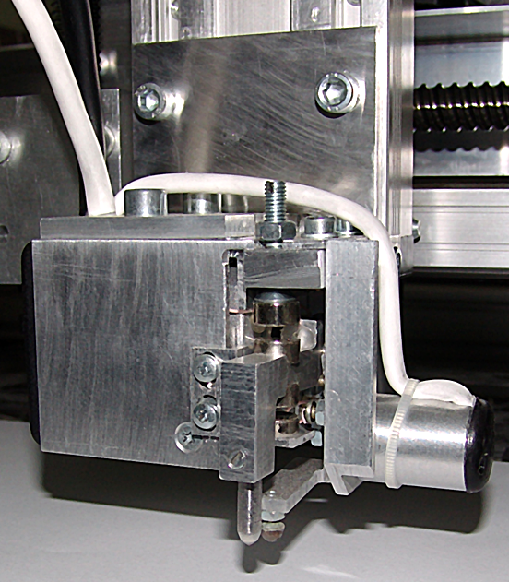  1  4  3  2 | - Magnet rocker  - Locknut  - Upper magnet adjustment screw  - Lower magnet adjustment screw
Figure 8.1: Adjusting the magnet

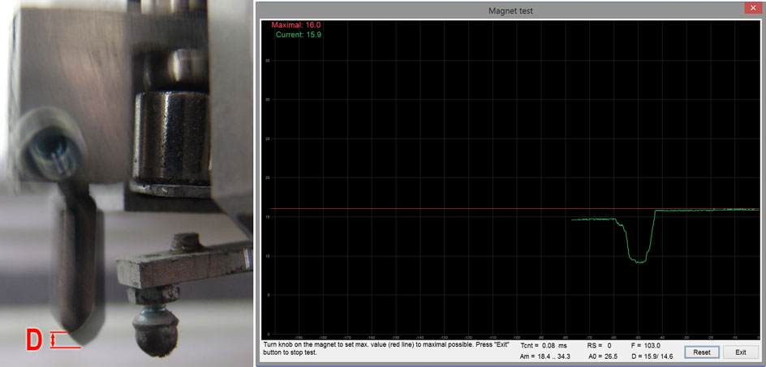
Figure 8.2: Magnet adjustment window in the Engrave
* Loosen locknut 2, Figure 7.1;
* In the "Magnet test" window click "Reset";
* By rotating the adjustment screw 3 in clockwise and counterclockwise directions adjust the maximum possible value for. Current D value is displayed in the graph, shown on Figure 8.2, as the green line. At the same time current D value is displayed on the control panel screen during the entire magnet test. To control the minimum value, use the graph shown as the red line. This graph displays the maximum currently reached amplitude value.
* When the maximum D value is reached, tighten the locknut 3;
* To quit the measuring mode in the "Magnet test" window, click "Exit";
* Before you start measuring and after the quitting the measurement mode, check the correctness of the magnet adjustment. If the Magnet move sup" message has appeared on quitting the adjustment mode, you need to turn around the magnet connector on the control board (item 8, Figure 9.1) and repeated the above procedure again.

Checking level sensor R
The level sensor R automatically tracks the unevenness of the workpiece surface during the engraving. If this level sensor operates incorrectly, the gap between the engraving tool and the workpiece surface will be arbitrary changing. The symptoms of the incorrect level sensor operation:
- When engraving a picture, dark, light or blank stripes appear on the image;
- The engraving tool scratches the workpiece surface.
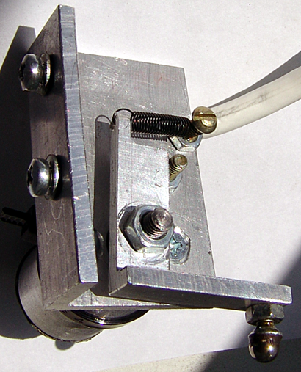  11  7  10  9  8  6  5  4  3  2  1  Figure 8.3: Level sensor | 1. Sensor casing  2. Bracket, fixing the sensor to the magnet  3. Sensor rocker  4. Sensing element  5. Locknut  6. Sensor shaft  7. Shaft retaining nut  8. Spring  9. Spring retaining screw and locknut  10. Support crew and locknut  11. Screws fixing the sensor to the magnet casing

Replacing sensitive element of the level sensor (item 4, Figure 8.3)
* Loosen nut 5;
* Unscrew bolt 4;
* Install new sensitive element;
* Tighten locknut 5. Make sure, that the bolt 4 does not overtwist.

Checking the sensor for mechanical faults
* While the sensor is not dismounted:
- Check vertical position of the sensitive element 4 with respect to the needle tip. When not contact with the workpiece surface ("in the air") the sensitive element 4 must be positioned lower the needle tip by 2..3 mm. To adjust the height, loosen screws 11 and move bracket 2 in vertical direction.
- Make sure, that the screws 11 are properly tightened;
- If the bolt of the sensitive element 4 is heavily worn from below, replace sensitive element 4;
- The bolt of the sensitive element 4 should not overtwist. Otherwise tighten the screw 5;
* While the sensor is dismounted, make sure, that the shaft 6, screws 9 and 10 have no backsplash. Check, whether the nuts 7, 9, 10 are properly tightened. If the spring 8 has loosened, replace it.

Checking the sensor readings
* You don't need to dismount the sensor;
* Do not push or lean on the Machine and the workpiece during the test;
* Turn on the Machine. In the Manual Mode position the tool head above the workpiece surface. Press <CLRN> and then pres <ENTER> keys on the control panel. The gap will be set automatically;
* While in the gap mode, store current R value displayed on the control panel screen (the variable may take any value);
* Use your finger to lift the level sensor tip 3 upward. When lifting the tip, the R value on the screen must change by several hundred units. If the value has changed by only several units, there is a fault;
* Release the tip, so that it is retained against the workpiece surface. Make sure, that the R value has returned to the initial figures. The R value should not significantly change as compared to the initial figure (permissible variation is ±3 units);
* Repeat the above steps 5..10 times. If the R value does not restores to initial figures, but increases of decreases with each new attempt, the is probably a fault;
* Possible faults:
a) Poor contact somewhere in the R wire. Check connectors:
- R wire – level sensor at the engraving head;
- R wire –R connector on the rear wall of the Control Unit;
- R flat cable –R connector on the print board inside the Control Unit (item 7, Figure 9.1).
Clean contacts with pure alcohol. Tighten both lock crews after the connector is plugged-in.
b) R wire break/short-circuit. Replace R wire.
c) R level sensor is damaged. Contact service center.

Checking X, Y, Z drives

Failure symptoms:
- when pressing the respective movement key the tool head does move in either one, or both directions, or moves in reverse direction;
- tool head sticks, when moving in one of the axis in the manual mode;
- in the course of engraving the image shifts in one of the X or Y axis.

Do the following:
- Check the end switches. Move tool head in the faulty axis in the manual mode. If, while the respective key is pressed, the respective coordinate value on the control panel screen does not change, check the end switches (see Section 8.5);
- Poor contact in one of the connectors. Check the connectors of the faulty coordinate wire both on the motor end and on the control panel end. Disconnect the wire connectors, clean with pure alcohol and reconnect. When reconnecting, make sure, that the locking screws on both ends of the connector are tighten properly and evenly;
- Check the flat cable connecting X/ Y/ Z sockets on the print board inside the control panel and the respective motor. Disconnect the flat cable, clean the connectors with pure alcohol and reconnect. Check for breaks the soldered contacts;
- Check the respective motor and drive mechanics. Turn off the machine, rotate the faulty coordinate drive crew by hand. If the crew rotates unevenly and sticks, the problem is in the drive or in the motor. Remove the respective motor. For motor removal details, see Section 9.6. Switch off the machine, try to rotate the motor and the screw by hand slowly and independently from each other. If the motor rotates unevenly, it should be replaced. If the ball screw drive rotates unevenly, sometimes sticks, it should be repaired.

Checking/disabling end switches

Failure symptoms:
- While in the manual mode, the tool head does not move in either one, or both directions in either axis, at the same time, when the respective movement key is pressed, the respective coordinate value on the control unit screen does not change;
- One of the symbols, indicating the triggering of one of the end switches, "X0", "X1", "Y0", "Y1", "Z0", is displayed in lower right corner of the screen, even when the tool head is positioned in the middle of the work field of the Machine. For the look of the screen in the Manual Mode, see Section 4.1.

Do the following:
* Check the end switch connectors. Two-contact plug is located nearby the respective motor, being connected with the motor by two independent wires. Check, whether the plug is connected properly and reliably. Connection polarity does not make sense, that is the plugs can be connected in either position;
* Check the connection of the faulty coordinate wire both form the control unit and the motor sides. Y-axis motor is connected to the control unit directly, ni wire is used. Disconnect the wire, clean terminals with pure alcohol and reconnect. When reconnecting, make sure, that the locking screws on both ends of the connector are tighten properly and evenly;
* If the problem persists, disable end switches in the Engrave program (see below). When the end switches have been disabled, continue operation of the Machine as usual, till the failure is corrected.

Disabling and enabling the end switches in the Engrave program
* Turn on the Machine. The Machine must be connected to PC;
* Open the Engrave. In the Engrave program use the menu command "File/Options…".
* In the "Options" window use the "End switches" list-box to set "No" for disabling the end switches and "Yes" for enabling the end switches;
* In the "Options" window click "Write to machine" button and then click "Ок". The "Options" window will be closed.

Replacing the Machine's components
WARNING! All the operations in connection with the components replacement are allowed only when the Machine is disconnected from 220 V main!

Replacing control board
18  17  16  15  13  12  11  10  9  8  4  7  6  5  14  14  14  2  3  1  Figure 9.1: Control Unit inside view | - Power Supply Unit  - Control Board  - Control Panel  - Z drive connector.  - Y drive connector  - X drive connector  - R, T sensors connector  - M connector  - RS-232 connector  - Control Panel connector  - Control Board power supply connectors (2 pcs.)  - Heat-sink with fan  - Power on button  - Crews, securing Control Unit to the Machine's frame  - Control Panel fasteners  - Control panel dimming light resistor  - Tool-grading wheel motor control relay  - USB connector

Control Board (item 2, Figure 9.1) is installed inside the Control Unit casing

Replacement procedure:
* Switch off the Machine. Disconnect 200 V power cable from mains
* Unplug the connectors 4, 5, 6, 7, 8, 9, 10, 11, 17.
* Unscrew 4 retaining nuts on the edges of the Control Board. Remove the board
* Install the new board in reverse order. Make sure, that connectors 4, 5, 6, 7, 10 are connected properly. These connectors have one color-marked (usually red, see Figure 9.1) wire
* Connectors 4, 5, 6, 7 must be connected so that the color-marked wire faces down
* Control Panel connector (10) must be connected so that the color-marked (red) wire faces up.
* Connectors 8, 9, 17, 18 are fitted with the key, ensuring the correct connection. If, when setting the gap, the "Magnet moves up" error has appeared, turn off the Machine and turn around the M connector (item 8) by 180 degrees
* Control board power supply connectors 11 are fitted with the keys, ensuring proper connection. Two wires from power supply unit (item 1), fitted with independent connectors, are connected to the connector 11. Connection order of these wires does not matter.

Replacing control panel
Control panel (item 3, Figure 9.1) is installed inside the Control Unit casing
* Turn off the machine. Disconnect power cable form mains
* Disconnect flat-cable from connector 10
* Remove both control panel fastener retaining screws 15 and remove the control panel
* Install new control panel. Flat cable connector 10 must be plugged to the socket, so that the color-marked (red) wire is faces up
* Turn on the Machine
* If the control panel screen is too dim or too bright (displayed symbols are almost black), adjust the dimming adjustment resistor 16, using the thin-tip screwdriver.

Replacing Power Supply Unit
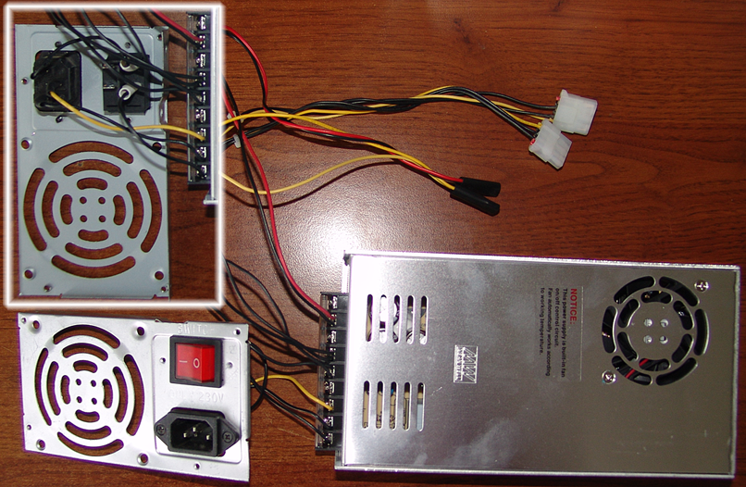  5  4  2  3  3  2  1  Figure 9.2: Power Supply Unit | - Power Supply Unit  - Connection to 200 V mains  - Power on button  - Connectors for the connecting of power on/off button on the front panel (2 pcs.)  - Control Board power supply connectors (2 pcs.).

Power Supply Unit (item 1 on Figure 9.1, item 1 on Figure 9.2) is installed inside the Control Unit casing. Power Supply Unit must be replaced together with the connector item 2 and the button item 3 on Figure 9.2.

Replacement procedure:
* Turn off the machine. Disconnect it from 220 V mains
* Disconnect two connectors (item11 on Figure 9.1, item 5 on Figure 9.2) on the print board
* Disconnect two connectors of power on/off button on the front panel (item 13 on Figure 9.1, item 4 on Figure 9.2)
* Unplug the connector item 2 and the button item 3, Figure 9.2
* Unscrew 4 power supply unit retaining screws on the rear wall of the Control Unit
* Remove Power Supply Unit
* Install the new Power Supply Unit and connect the connectors in reverse order
* Print board power supply connectors (item 11, Figure 9.1) are fitted with the keys, ensuring proper connection. Connect two wires with independent connectors (item 5, Figure 9.2) in arbitrary order
* Connect power on/off button connectors item 4 on Figure 9.2 to the power on/off button item 13 on Figure 9.1, so that the red wire is connected to the upper contact, and the yellow wire is connected to the lower contact.

Replacing Control Unit
* Turn off the machine. Disconnect it from 220 V mains
* Disconnect all the connectors of X, Y, Z, R, M, RS wires on the rear panel of the Control Unit
* Unscrew screws 14, Figure 9.1, inside the Unit, remove the Unit
* Install the new Control Unit in reverse order. Make sure, that all the connectors of X, Y, Z, R, M, RS wires on the rear panel are screwed evenly.

Replacingв X, Z, R, M wires.
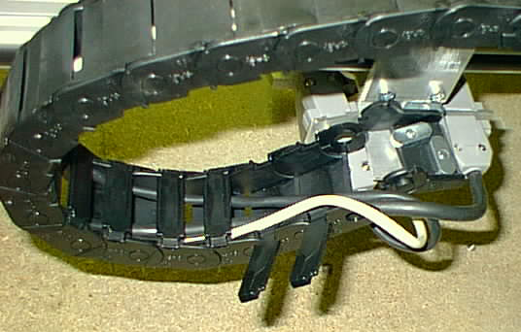  2  1  Figure 9.3: Cable track | * Following wires are used in the Machine:  - X drive cable  - Z drive cable  - Level sensor R cable  - Magnet M cable  - Y drive motor is connected to the control unit directly with no any intermediary cables

* It is recommended to check the integrity of a new cable before installing it into the cable track and before you have replaced the old cable by connecting the new cable "on the fly"

Replacement procedure:
* Turn off the Machine, disconnect both ends of the wire
* Remove the cable from cable track (see Figure 9.3). Each segment of plastic cable track is fitted with cover (item 1), which is easy to open using a screwdriver
* To remove the cable, disconnect the last segment of cable track 2, using a screwdriver
* Install the new cable in reverse order.

Replacing X, Y, Z drives
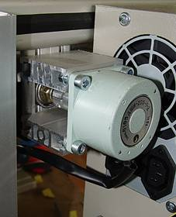  5  6  6  4  1  2  3  Figure 9.4: Motor mounting | Figure 9.4 shows the Y drive mounting. Mountings of X and Z drives have similar structure  1. Stepper motor  2. Motor cable  3. Motor retaining screw (4 pcs.)  4. Screw washer (4 pcs.)  5. Coupler  6. So-called "sleeve" with motor mounting holes  Replacement procedure:  * Turn off the Machine  * Disconnect the stepper motor connector. Z drive is connected to X cable, Y drive is connected directly to the Control Unit, Z drive is connected to Z cable  * Disconnect additional two-contact connectors of the end switches. X drive has two connectors, Y and Z drive has by one connector each.
* Remove screws 3 and washers 4
* Remove motor 1 together with the half-piece of coupler 5
* Install new motor. Make sure, that you have installed flexible sprocket between two half-pieces of the coupler
* Install and slightly tighten screws 3
* Connect motor cable to the connector. Connect the end switch connectors (separate two-contact connectors
* Turn on the machine in the manual mode and make the carriage travel the whole length of the driving screw, while tightening screws 3. Tighten the screws in diagonal order, in order to install the motor with no skewing in respect of the driving screw.

Replacing Z drive of the tracking head on Graphic-3K machines
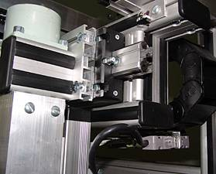  1  2  Figure 9.5: Z drive mounting of Graphic-3K machines | * Turn off the machine  * Disconnect the three cables: Z motor cable, level sensor cable and magnet cable item 1  * Loosen 4 head retaining screws item 2 and remove the head by pulling it sideward off the grooves of the Z drive carriage  * Install the new head in reverse order

Replacing Z drive of the tracking head on Graphic-3KP machines
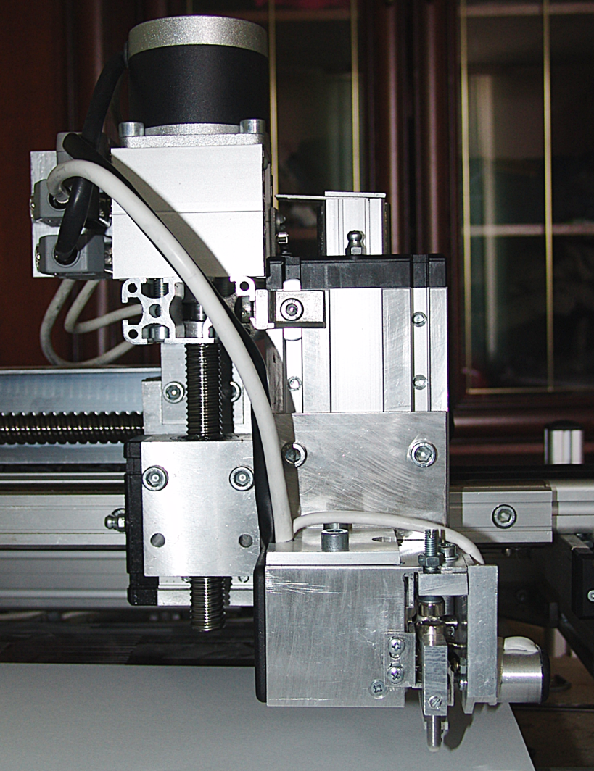  11  10  9  9  7  4  3  2  5  6  1  8  Figure 9.6: Z drive mounting of Graphic-3KP machines | - Stepper motor Z  - Screw of the ball screw drive  - Nut of the ball screw drive  - Slide-block  - Guide  - Magnet  - Level sensor  - Z motor, VG and level sensor connectors  - Fastening screws of the ball screw drive nut  - Slide-block fastening screw  - Engraving head fastening screws

Replacement procedure:
* Using the machine's control panel, move up the head in the Z axis
* Switch off the machine
* Unplug Z drive connector (item 8), magnet and level sensor connectors
* Loosen the screws 11 and remove the tool head
* Loosen the crew (item 10) and move the slide-block (item 4) down, so that the corner with the screw 10 is not linked to the slide-block (item 4)
* Loosen the screws 9. While moving the ball screw-drive nut item 3 to the left, remove Z-drive assembly, including the stepper motor (item 1), ball screw-drive (item 2) and the ball screw-drive nut (item 2).
WARNING! When removing Z drive don’t remove the ball screw-drive nut 3 from the ball screw-drive screw 2! Removing of this nut will result in scattering and loss of balls. This in turn will require the replacement of the ball screw-drive nut. When transporting the assembly, the ball screw-drive nut must be positioned at least at 10 mm distance from the screw end (see red arrow on Figure 9.6).

* Install the new drive in reverse order
* When installing the head make sure, that the screw of the ball screw-drive (item 2) is parallel to the guide (item 5). To adjust the positioning, loosen screws 9. Using the machine's control panel, switch the machine to the manual mode and make A drive move up and down, while gradually tightening the screws 9.

Replacing impact head
* Using the machine's control panel, move up the head in the Z axis in the manual mode
* Turn off the machine
* Unplug connectors 8 (Figure 9.6) of Z drive, VG and the level sensor
* Loosen the crews 11 (Figure 9.6) and remove the impact head
* Install the hew impact head in reverse order.

Replacing and adjusting the level sensor position
2..3 mm  2  1  Figure 9.7: Impact head (rear view with cover off) | - Level sensor  - Level sensor fastening screws  Replacement procedure:  * Remove multifunctional impact head (see Section 9.9);  * Remove rear cover of the impact head  * Unplug the level sensor connector  * Remove two screws (item 2), remove sensor (item 1)  * Install the new sensor in reverse order  * Connect the level sensor connector with the color-marked (white) wire directed outward  * When installing the engraving needle, the bolt (ball) on the level sensor presser must be positioned by 2…3 mm lower than the engraving needle tip. Adjust the position by moving the level sensor up or down, having loosened the screws (item 2).

Checking the engraving tool (needle) wear
Subject to special order, the machine may be optionally equipped with the engraving tool wear monitoring system.
The System consists of the following components:
1. Digital microscope
2. Digital microscope mounting bracket
3. Digital microscope software either on a separate CD, or on the Engrave installation CD

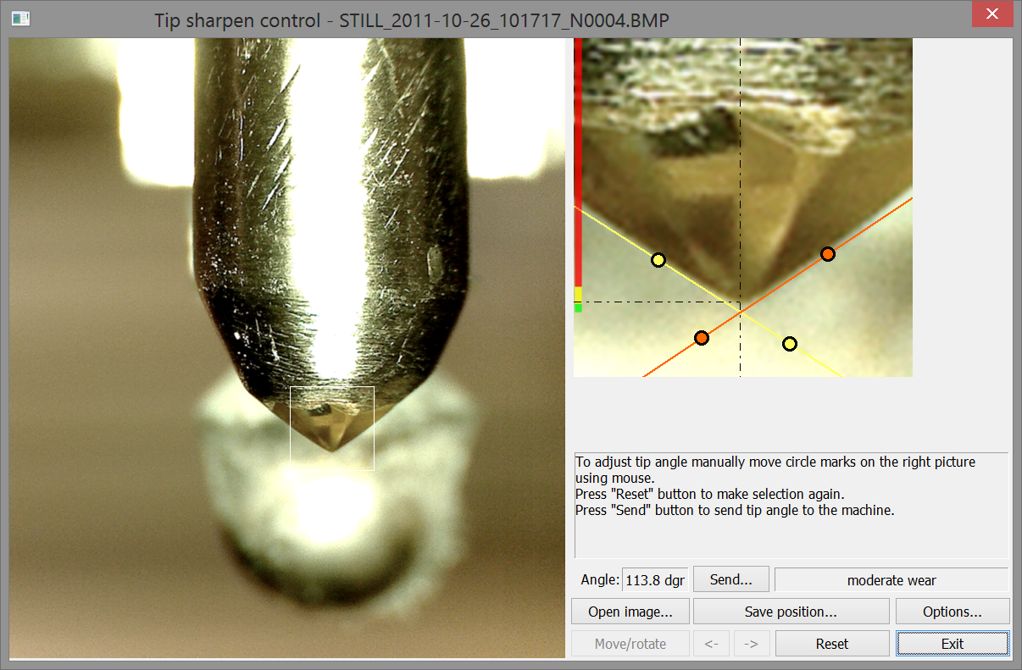
5

5

6

7

8

4

4

3

2

1

Figure 11.1: Tool grinding window in the Engrave program

1. Enlarged digital image of the engraving needle
2. Needle tip selection frame
3. Enlarged needle tip image fragment
4. Guidelines
5. Guideline adjustment markers
6. Needle wear indicator
7. Pop-up help window
8. Wear data window.

Installing tool wear monitoring system
Before installing the system make sure, that the end switches X0, Y0, Z0 are OK and work properly. Use "Options" window of the Engrave program to enable the end switches
1. Fix the microscope mounting bracket to the machine's frame
2. Install digital microscope software on your PC
3. Install digital microscope into the bracket
4. Connect microscope to one of the USB ports of your PC. Turn on the microscope and open microscope control program on your PC
5. Adjust microscope position. Make sure, that when moving the tool in the manual mode, the engraving head does not touch the microscope casing within the entire movement range, from one end switch triggering position to another, otherwise the tool head may damage microscope.

Checking the needle wear
In the Engrave program use the menu command "Service/Tip check", or click the "Tip check" button (item 12, Figure 3.3) in the bottom status panel of the Engrave.

WARNING! Needle tip wear checking is impossible, if the engraving is still in progress, for example, between the first and the second engraving passes, otherwise the workpiece zero point coordinates will be lost and the repeated engraving pass will become impossible.

* Upon entering the needle tip check command, the needle will be moved to the zero point of the machine using the end switches X0, Y0, Z0. Then the tool will be moved away from the end switches and repositioned to the tip viewing point, that is the position, where the needle tip is in viewing filed of the microscope;
* After the tool is moved to the tip viewing position, "Tip sharpen control" window will be opened in the Engrave (see Figure 11.1), microscope control program will be launched (Anyview or other similar program, depending on specific microscope model);
* If microscope control program has launched automatically, check Windows task manager and make sure, that there is only one copy of this program is launched. Make sure, that the microscope control software was installed on your machine control PC. You may also want to launch microscope control software manually;
* Enlarged image of the engraving needle tip will appear in the microscope control program window (see Figure 11.1):
- If the needle tip is not in the viewing field of the microscope, switch to the manual mode and, using the control panel of the machine, move the tool accordingly, till the needle tip is well seen on the monitor of your PC. You may store this tool position to be used in the future. To store the needle position click "Save position…." button in the "Tip sharpen control" window of the Engrave. Confirm you choice in the confirmation dialog window, by clicking "Yes" in reply to the "Save position?" question;
- If it is impossible to adjust the needle position in the manual mode, adjust the microscope bracket position instead. You can additionally adjust height of the engraving tool by loosening two impact head casing retaining screws and moving the impact head in the vertical axis;
- If the needle tip image is hazy, adjust contrast using the relevant screw on the microscope casing;.
- If the needle tip is hardly visible against the dark background, place a sheet of white paper behind the needle and use it as the background;
* Using the respective tool of the microscope control program, make photo of the needle tip. This picture should immediately appear in the left part of the "Tip sharpen control" window in Engrave (item 1, Figure 11.1). If it did not happen, open it manually using the "Open picture..." button in the "Tip sharpen control" window.
* To ensure, that the wear control system algorithm works properly, the needle tip on the picture in the "Tip sharpen control" window must be headed downward. Use "<-" and "->" buttons to rotate the image clockwise or counterclockwise. To rotate the image arbitrary click "Move/Rotate". Rotate the image with the mouse by holding the right mouse button, or move the image by holding the left mouse button;
* To make the needle tip image rotate by some given angle every time you open the "Tip sharpen control " window, click "Options..."and in the "Tip control and sharpen" set the desired angle in degrees in the field "Rotate Photo".
* Using the marquee (item 2 ob Figure 11.1) select the needle tip on the image and double-left-click the mouse. The enlarged view of selected fragment will appear in the right window (item 3, Figure11.1). Sharpening angle of the needle tip in degrees will be calculated automatically (see "Angle" field). Needle wear will be displayed on the indicator (item 6) and in the wear information window (item 8). Green zone corresponds to initial wear of the needle, yellow zone indicates moderate wear, and red zone indicates critical wear of the needle, when the needle replacement or sharpening is required;
* You may want to set the sharpening angle manually. You can move both yellow and red guidelines (item 4) by clicking the left mouse button and holding the marker (item 5). Guidelines must exactly follow the needle profile, sharpening angle value will change accordingly.

